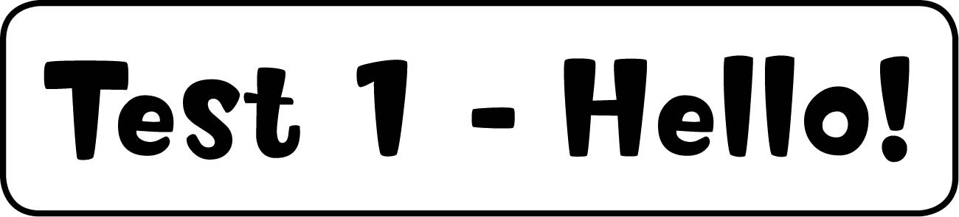

1 Listen and colour. (5 marks)

six – grey, two – blue, nine – yellow, seven – orange, eight – green, five – brown

2 Read and tick or cross. (5 marks)
2 , 3 , 4 , 5 , 6 

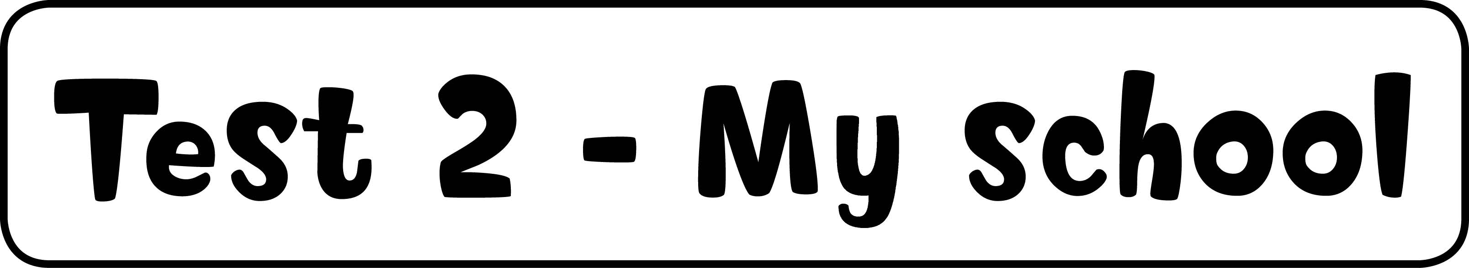

1 Write the words. (5 marks)
2 table, 3 pen, 4 eraser, 5 chair, 6 pencil

2 Listen and match. (5 marks)

1 Hello. Hello. 2 What’s your name? I’m Sarah. 3 Who’s that? That’s Ben.
4 Goodbye. Goodbye. 5 How old are you? I’m eight. 6 How are you? I’m fine, thank you.

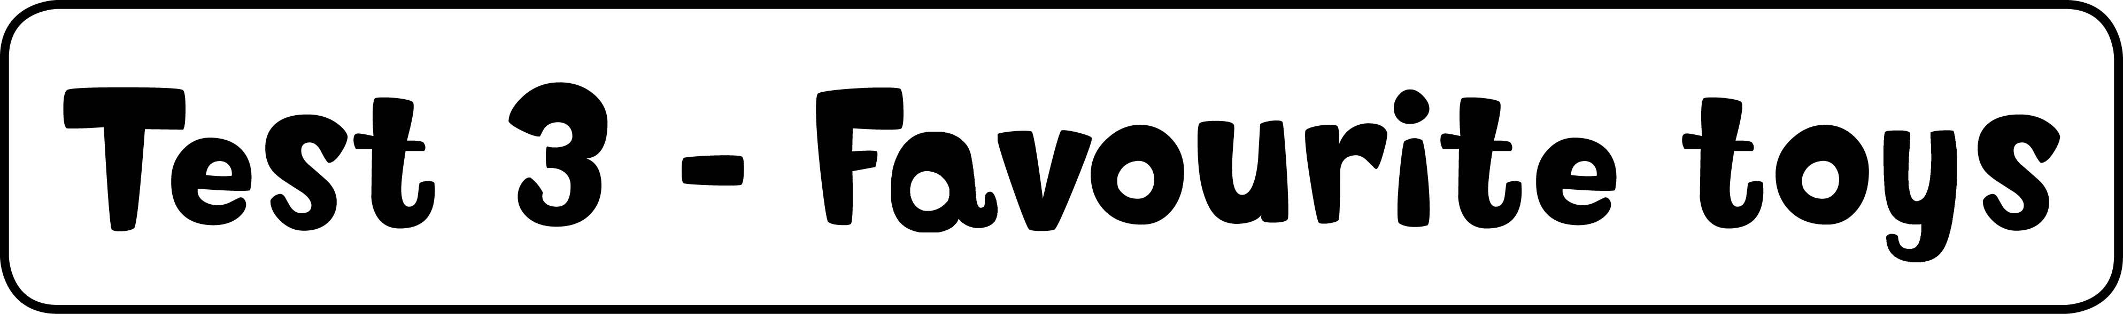

1 Listen and write the number. (5 marks)
doll and train – 5, car and computer – 2, computer and pencil – 6, doll and box – 3,
chair and ball – 4


1 The pencil is on the chair. 2 The car is on the computer. 3 The doll is in the box.
4 The ball is under the chair. 5 The train is next to the doll.
6 The pencil is next to the computer.

2 Look and write the words. (5 marks)
2 computer, 3 ball, 4 doll, 5 car, 6 bike

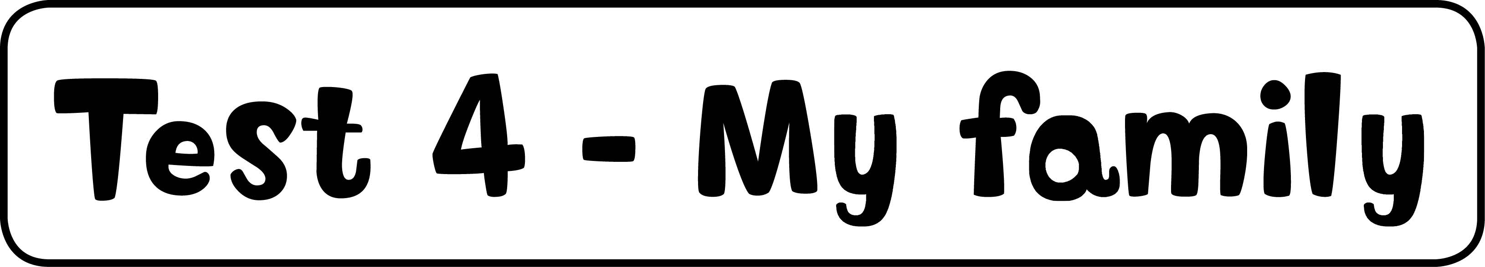

1 Look and write. (5 marks)
Grandma Star – grandmother, Mr Star – father, Mrs Star – mother, Simon – brother,
Suzy – sister

2 Listen and write the number. (5 marks)
2 d – sad, 3 f – young, 4 c – old, 5 e – beautiful, 6 b – ugly


1 happy, 2 sad, 3 young, 4 old, 5 beautiful, 6 ugly



1 Colour. (10 marks)
1 – one, 2 – two, 4 – four, 6 – six, 10 – ten

2 Listen and tick or cross. (5 marks)
2 , 3 , 4 , 5 , 6 

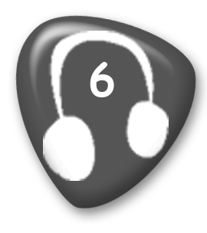
1 It’s a hippo. 2 It’s a table. 3 It’s a monkey. 4 He’s Alex. 5 It’s a pen. 6 She’s Meera.

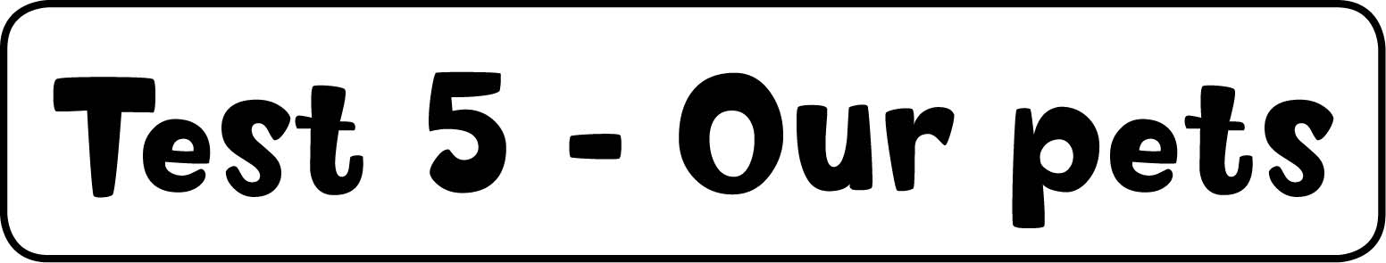

1 Listen and colour. (5 marks)
dog – black, bird – blue, fish – orange, mouse – grey, horse – brown

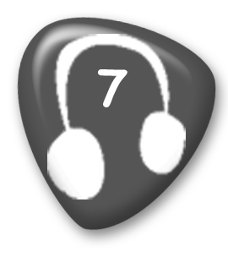
A black and white cat. A grey mouse. An orange fish. A brown horse. A blue bird.
A black dog.

2 Look and write. (5 marks)
2 short, 3 dirty, 4 long, 5 small, 6 big

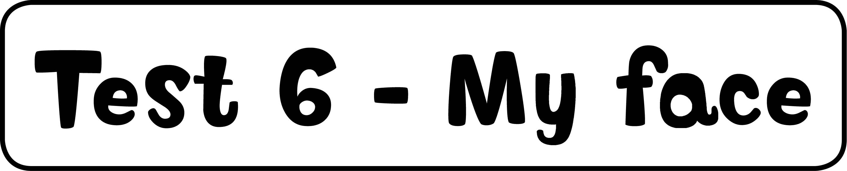

1 Complete and match. (5 marks)
2 face, 3 ears, 4 mouth, 5 teeth, 6 hair

2 Match. (5 marks)
2 Meera and Stella, 3 monster, 4 bunnies, 5 crocodile, 6 snake

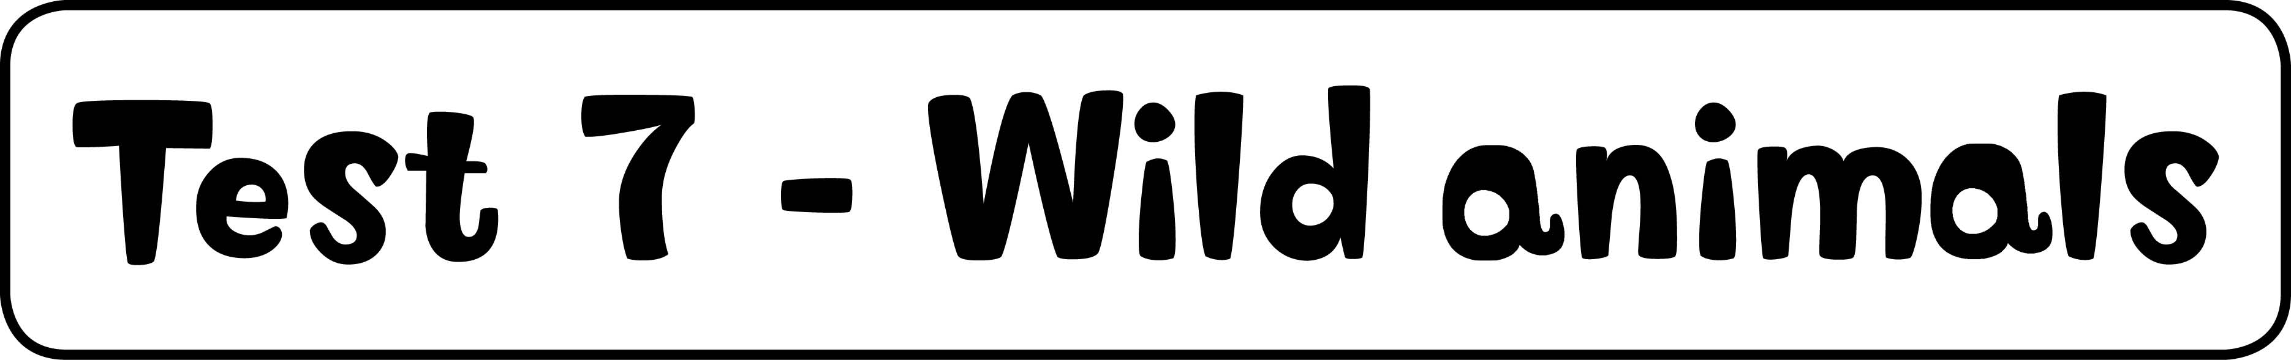

1 Write. (5 marks)
2 elephant, 3 hippo, 4 giraffe, 5 snake, 6 tiger

2 Look and circle. (5 marks)
2 They’ve got, 3 They’ve got, 4 They haven’t got, 5 They haven’t got, 6 They’ve got

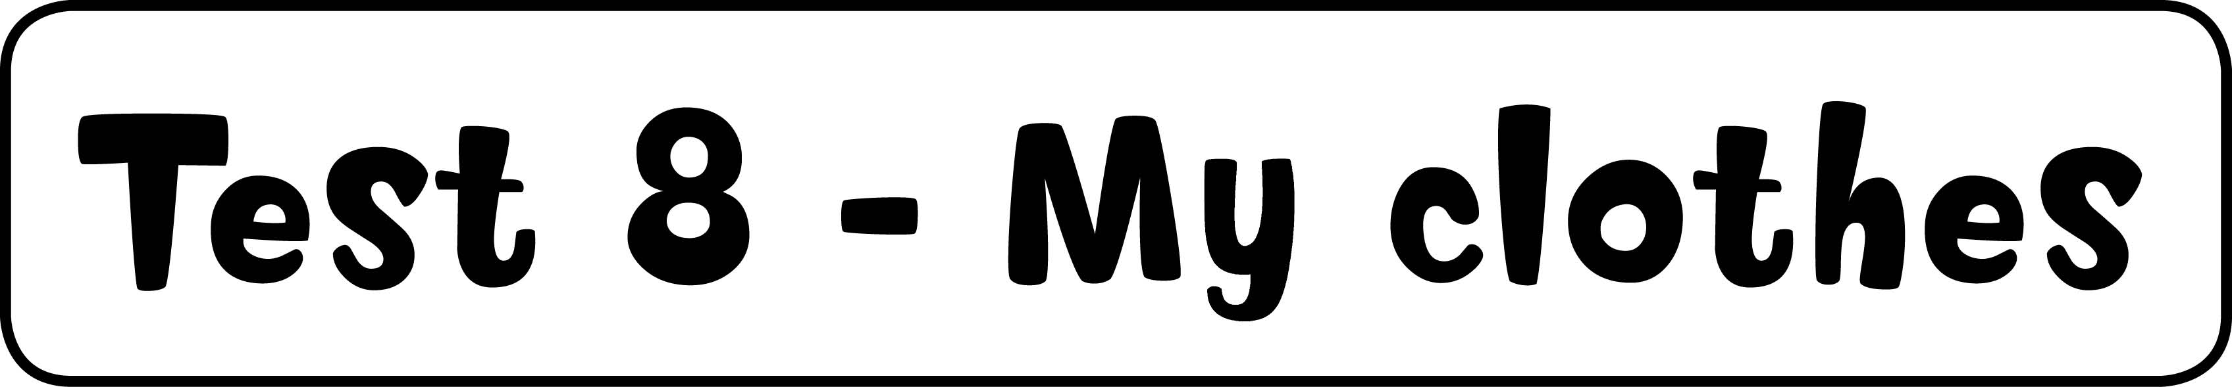

1 Look and write. (5 marks)
2 trousers, 3 shoes, 4 skirt, 5 jacket, 6 T-shirt

2 Listen and colour. (5 marks)
Boy – red T-shirt, green trousers
Girl – yellow T-shirt, purple skirt, orange socks


He’s got black shoes. He’s got a red T-shirt and green trousers.
She’s got a yellow T-shirt and a purple skirt. She’s got orange socks.

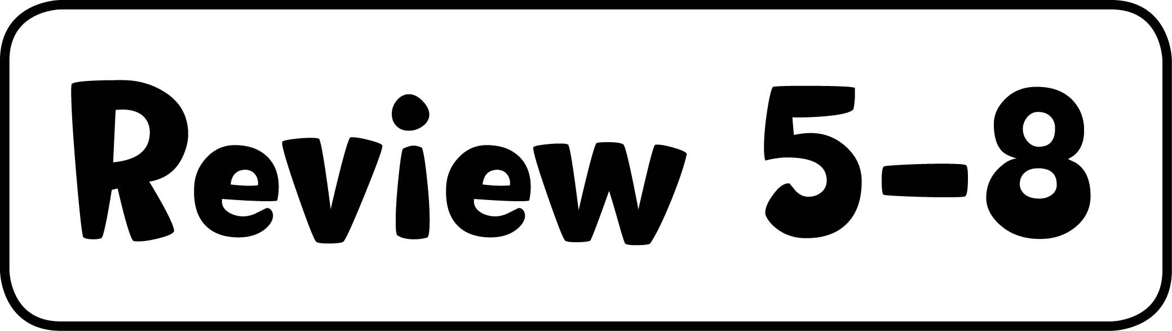

1 Match and write. (10 marks)
Pets – horse, dog
Face – nose, hair
Wild animals – tiger, giraffe, hippo
Clothes – jacket, socks, skirt

2 Listen and number. (5 marks)
Mr Star – 4, Grandpa and Grandma Star – 3, Suzy and dog – 6, snake – 5,
elephants – 2


1 It hasn’t got arms. 2 They haven’t got hair. 3 They’ve got white hair.
4 He’s got a white T-shirt. 5 It hasn’t got arms or legs.
6 She’s got a big black and white dog.

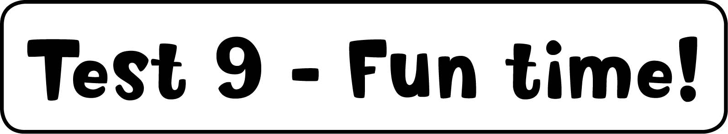

1 Write the words. (5 marks)
2 ride, 3 horse, 4 tennis, 5 play, 6 basketball

2 Look and circle. (5 marks)
2 can, 3 can’t, 4 can’t, 5 can’t, 6 can

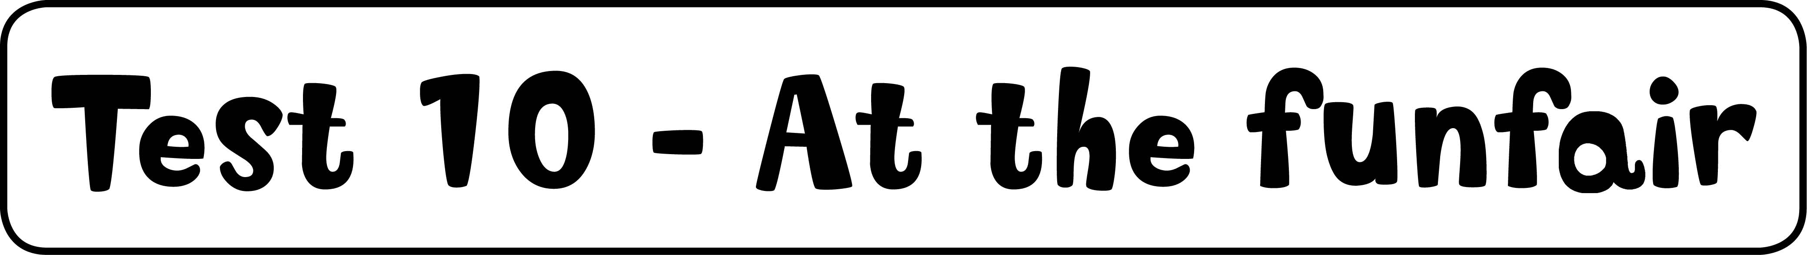

1 Match. (5 marks)
2 d, 3 f, 4 a, 5 e, 6 b

2 Listen and colour. (5 marks)
bus – blue, plane – red, boat – green, helicopter – yellow, motorbike – purple


A black lorry. A yellow helicopter. A red plane. A blue bus. A green boat.
A purple motorbike.

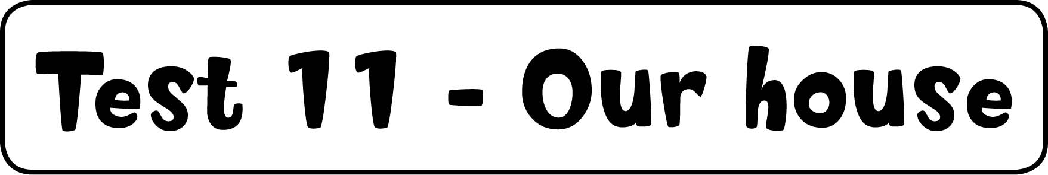

1 Look and draw lines. (5 marks)
Top floor, left to right: bathroom, bedroom
Bottom floor, left to right: living room, hall, kitchen, dining room

2 Order and write. (5 marks)
2 She’s reading a book. 3 He’s sitting on a chair. 4 They’re listening to music.
5 He’s driving a car. 6 They’re playing tennis.

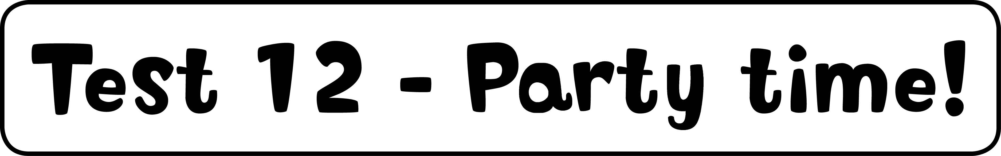

1 Find the words and write. (5 marks)
2 chocolate, 3 burger, 4 ice cream, 5 banana, 6 cake

2 Listen and match. (5 marks)
Sam – bananas , chocolate 
Sue – ice cream , cake , apples 

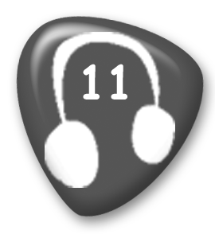
Sam: I don’t like burgers. I like bananas. I don’t like chocolate.
Sue: I like ice cream. I don’t like cake. I like apples.

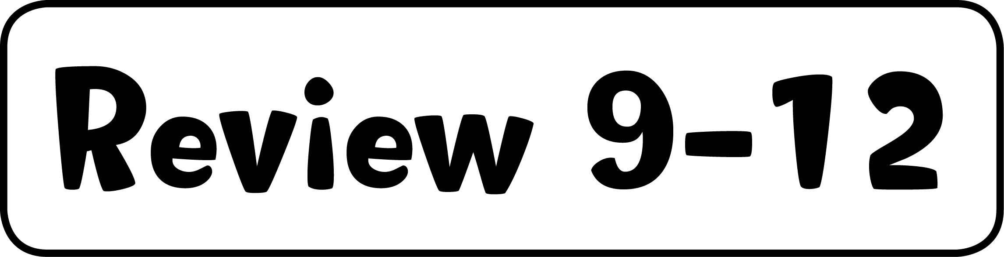

1 Read and circle. (5 marks)
2 talk, 3 walk, 4 read, 5 play, 6 swim

2 Look and write the words. (5 marks)
2 eating, 3 swimming, 4 flying, 5 watching, 6 driving



1 Look and write. (5 marks)
2 in, 3 on, 4 under, 5 on, 6 next to

2 Read and write. (5 marks)
2 tigers, 3 giraffes, 4 elephants, 5 snakes, 6 crocodiles

3 Listen and tick or cross. (5 marks)
2 – right centre, 3 – bottom left, 4 – bottom right, 5 – left centre, 6 – top left

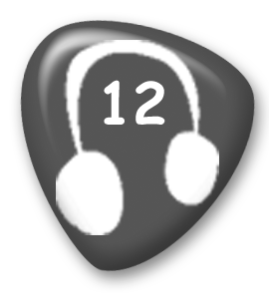
Boy: She can play football. She can’t ride a bike. She can sing.
Girl: He can’t play the guitar. He can ride a horse. He can’t play tennis.

4 Read and draw lines. (5 marks)
play the guitar – , ride a bike – , ride a horse – , sing – , play tennis – 

