Name: | Class:

①Look and draw lines. Mark / 5

bedroom kitchen dining room living room bathroom hall

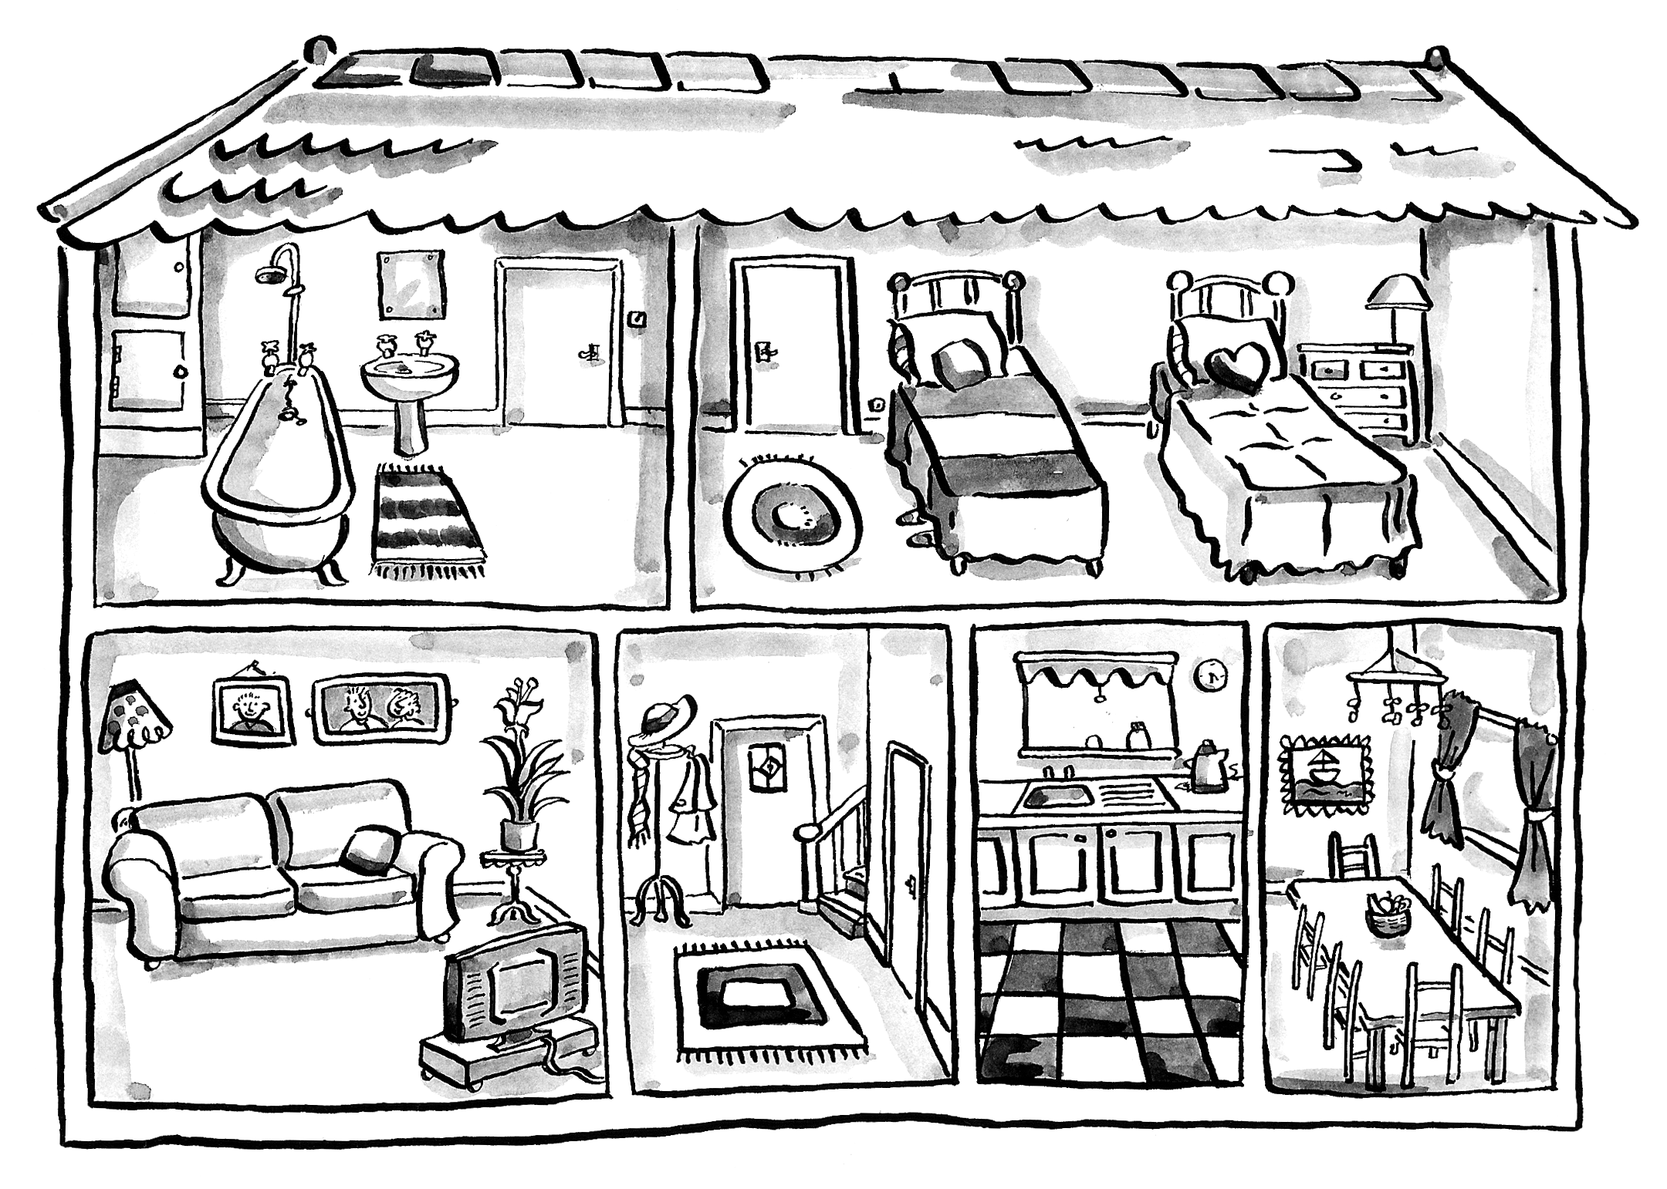

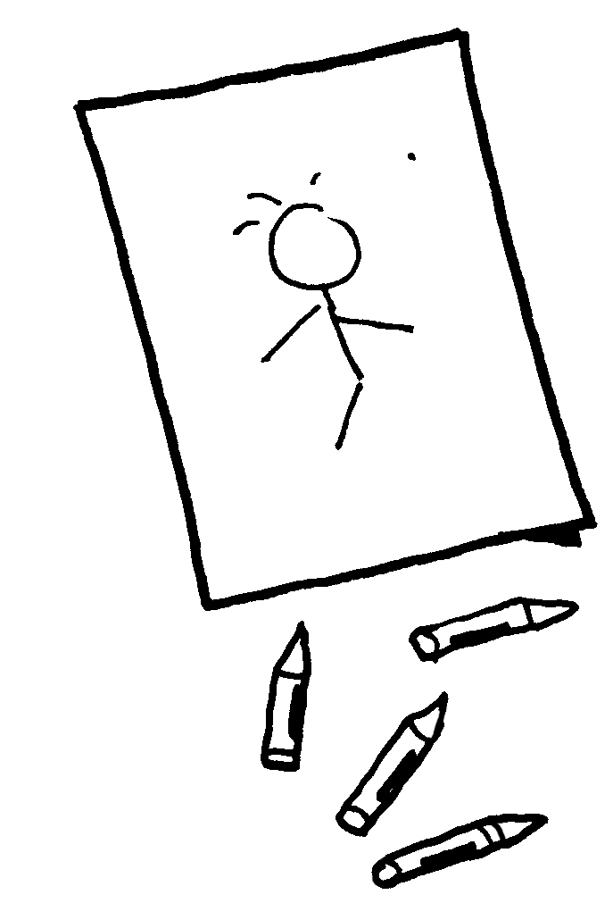
②Order and write. Mark / 5

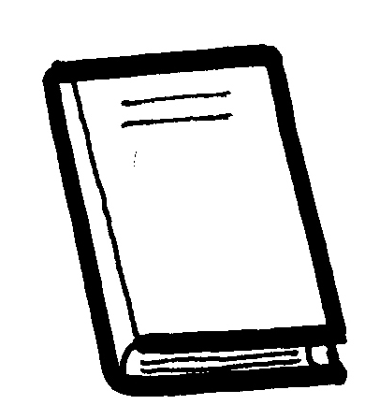
❶ drawing / He’s / a / picture. He’s drawing a picture.

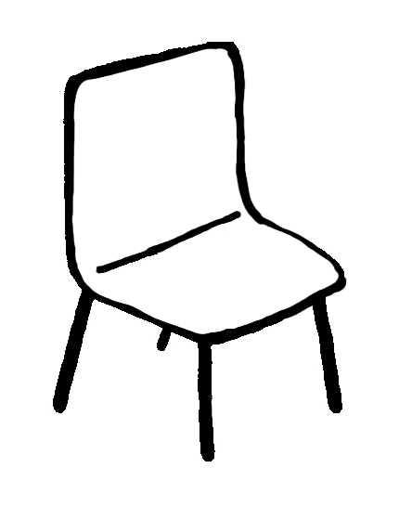
❷ a / reading / She’s / book. _____________


❸ on / sitting / a / He’s / chair. _____________

❹ to / They’re / music. / listening ______________
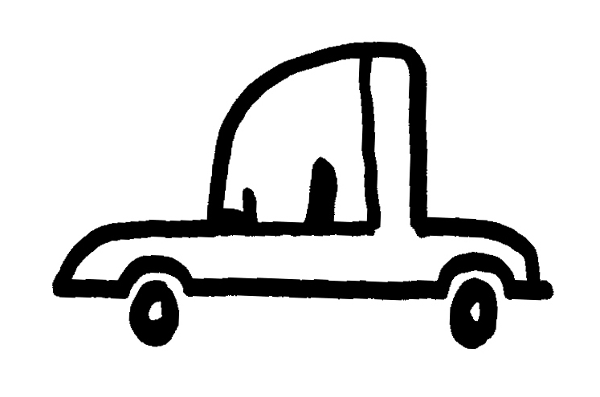
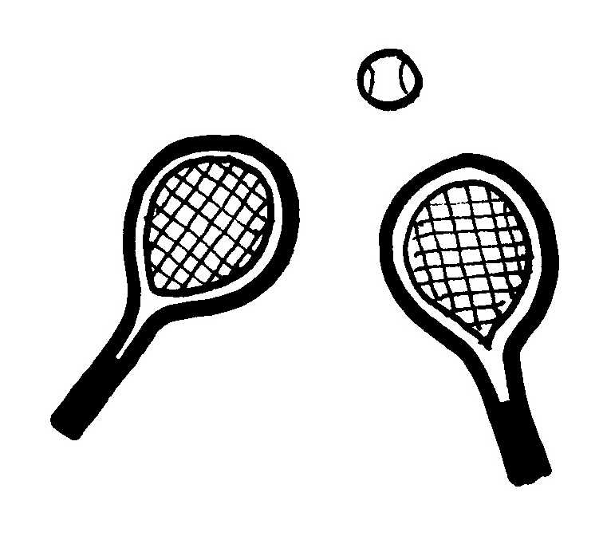
❺ car. / a / driving / He’s ________________

❻ tennis. / They’re / playing ____________

Total unit mark / 10

