Name: | Class:

①Look and write. Mark / 5

next to under on in next to on

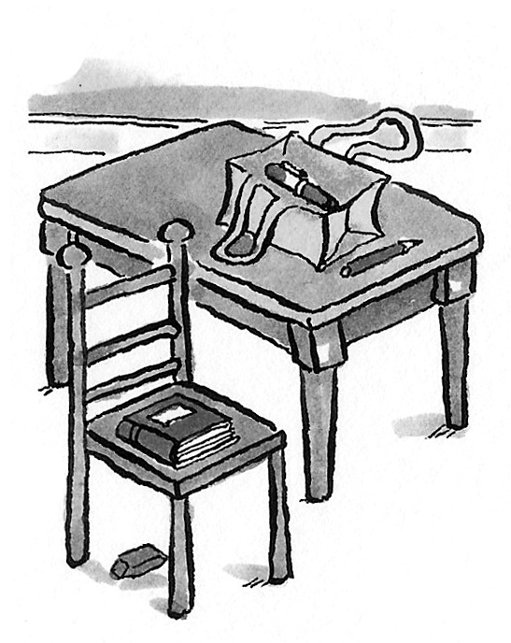
❶ The chair is next to the table.
❷ The pen is ____________ the bag.
❸ The bag is ____________ the table.
❹ The eraser is ____________ the chair.
❺ The book is ____________ the chair.
❻ The pencil is ___________ the bag.

②Read and write. Mark / 5

elephants snakes crocodiles giraffes hippos tigers
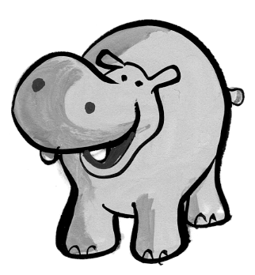
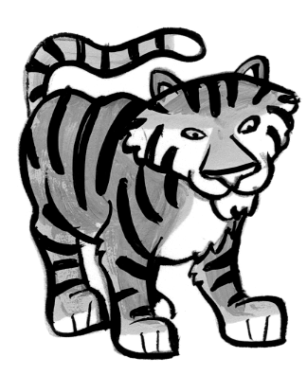
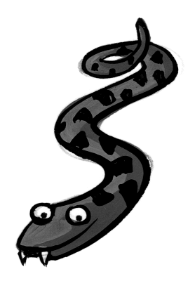
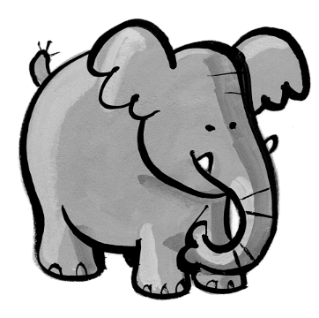
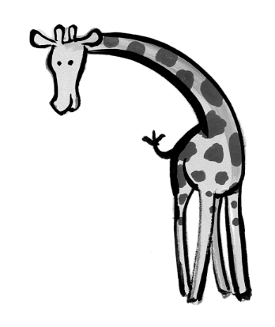
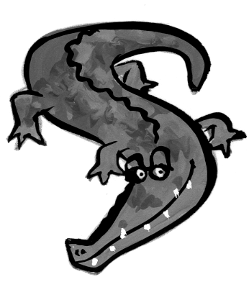

❶ They’re dirty and grey. They haven’t got hair. hippos
❷ They’re black and orange. They’ve got big teeth. _________
❸ They’re brown and yellow. They’ve got small heads. _________
❹ They’re big and grey. They’ve got long noses. ___________
❺ They’re long and green. They haven’t got legs. __________
❻ They’re green. They’ve got big teeth and short legs. _______

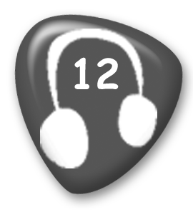
③ Listen and tick () or cross (). Mark / 5
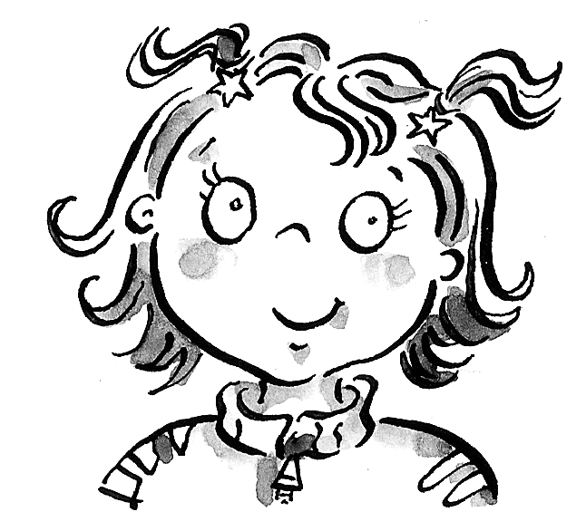
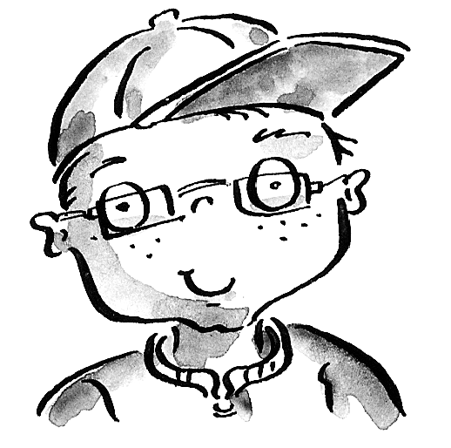

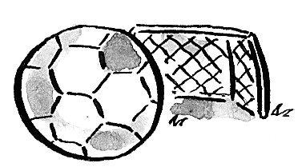
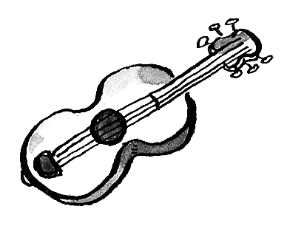

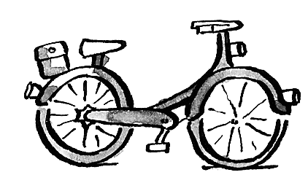
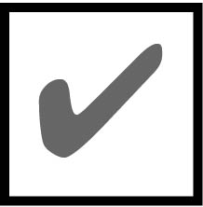
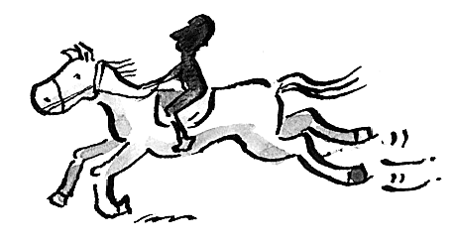
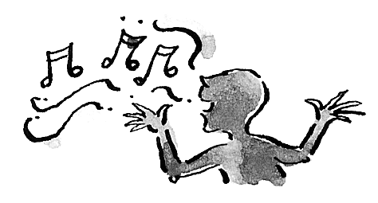
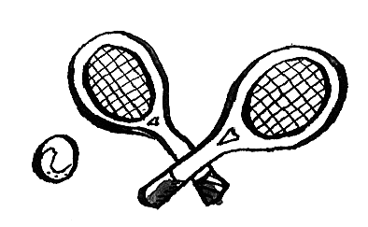

④Read and draw lines. Mark / 5
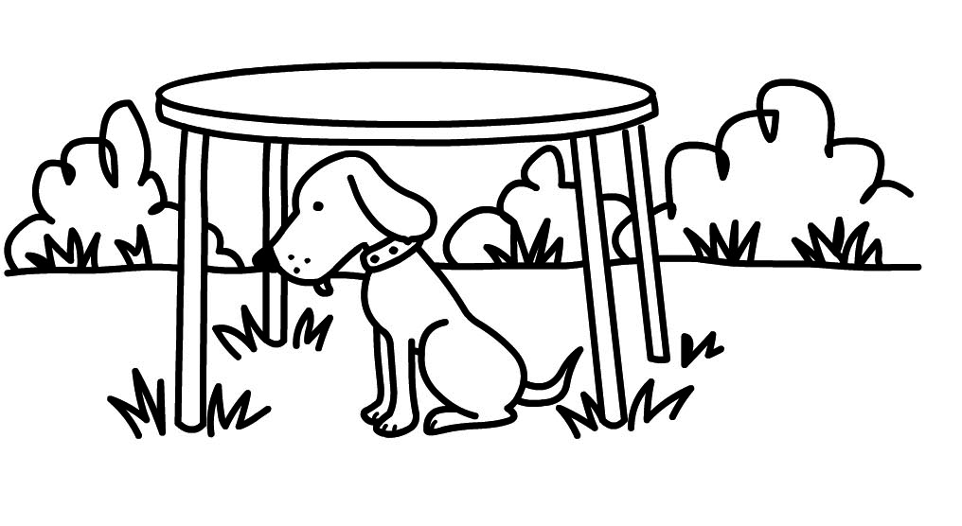
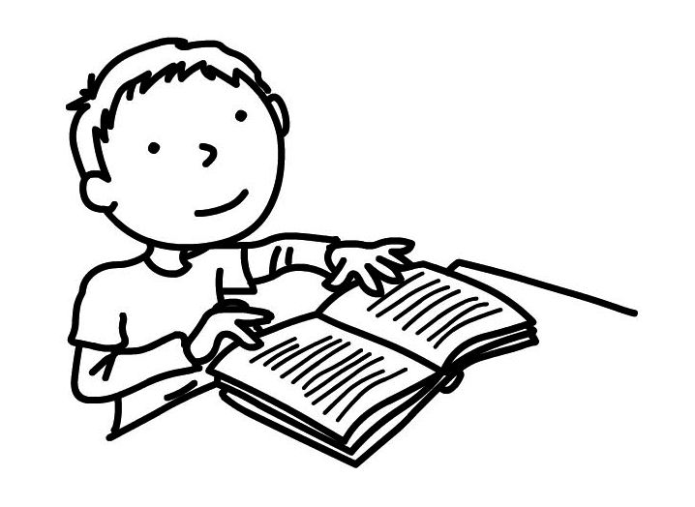
❶ He’s reading a book.

❷ The cat’s eating a fish.
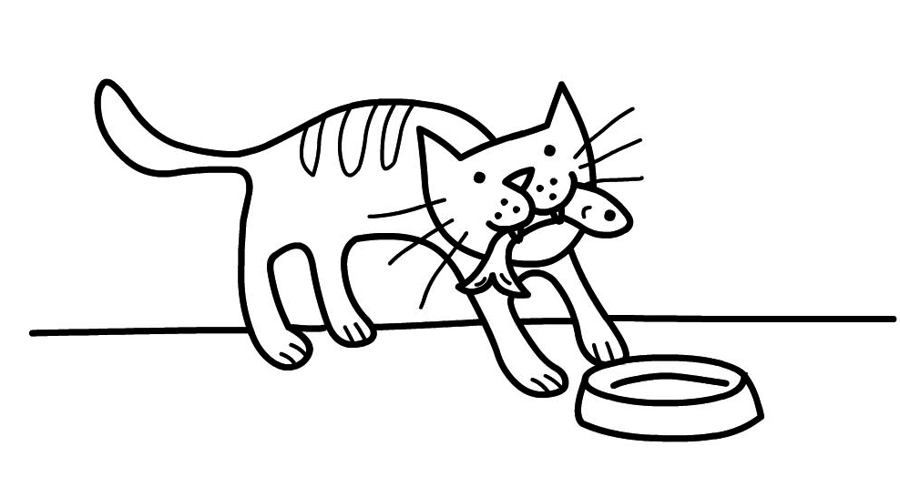
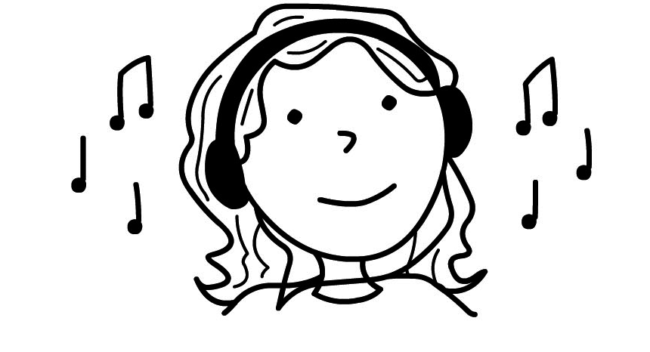
❸ He’s watching TV.

❹ He’s drawing a picture.
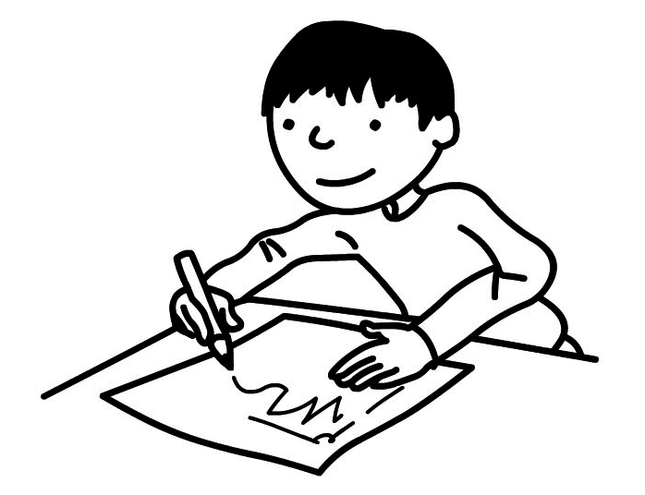
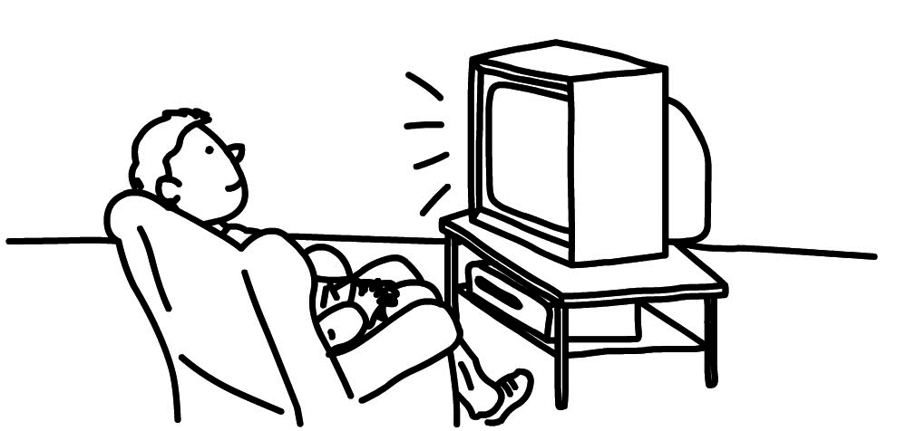
❺ She’s listening to music.

❻ The dog’s sitting under the table.

Total end of level mark / 20

