Name: | Class:

①Read and circle. Mark / 5


❶ Maskman can fly / drive a helicopter.
❷ Monty can talk / fly.
❸ Simon can walk / drive to school.
❹ Stella can read / sing a book.
❺ Mr Star can fly / play the guitar.
❻ A dog can swim / drive.

②Look and write the words. Mark /10

playing driving flying swimming watching eating
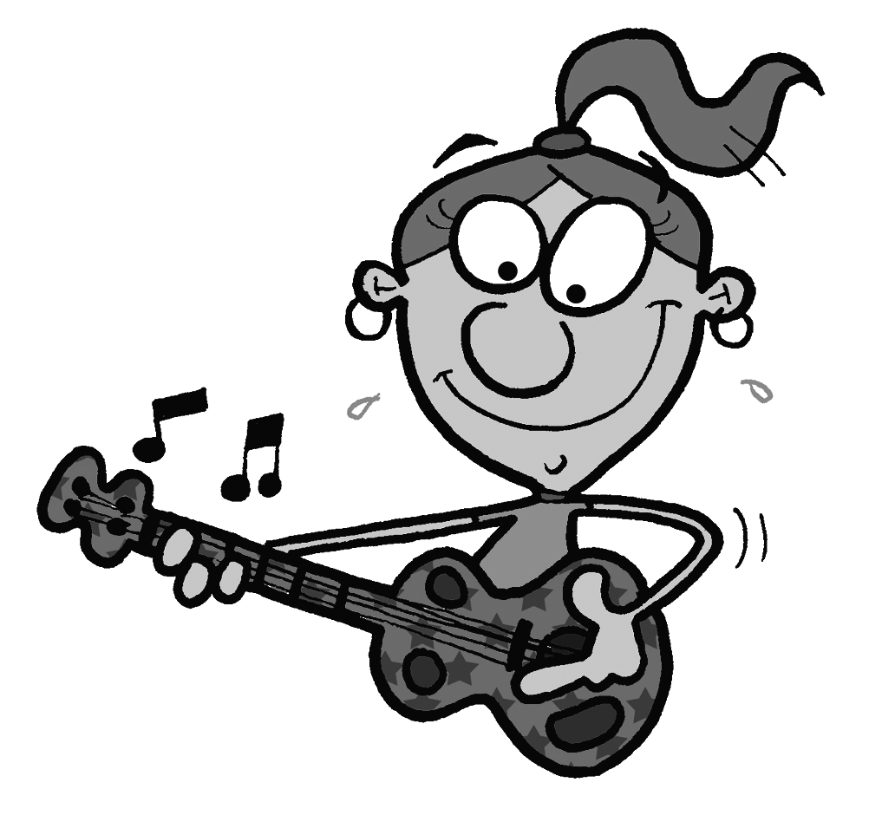
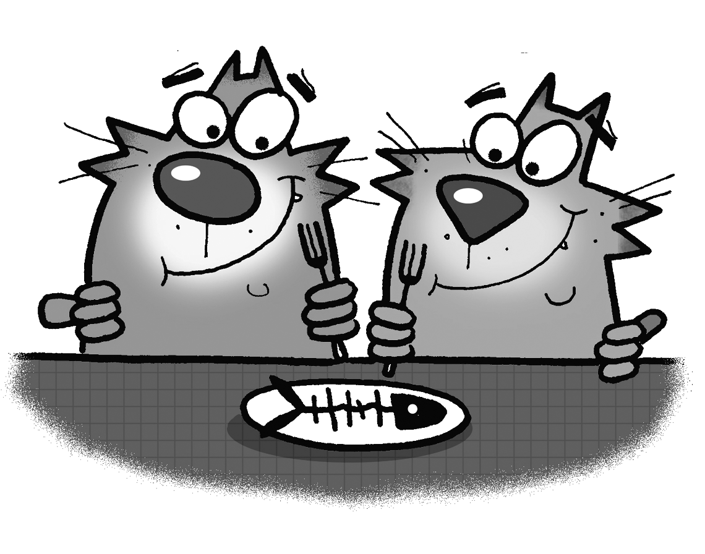
❶ She’s playing the guitar.

❷ They’re _____________ fish.
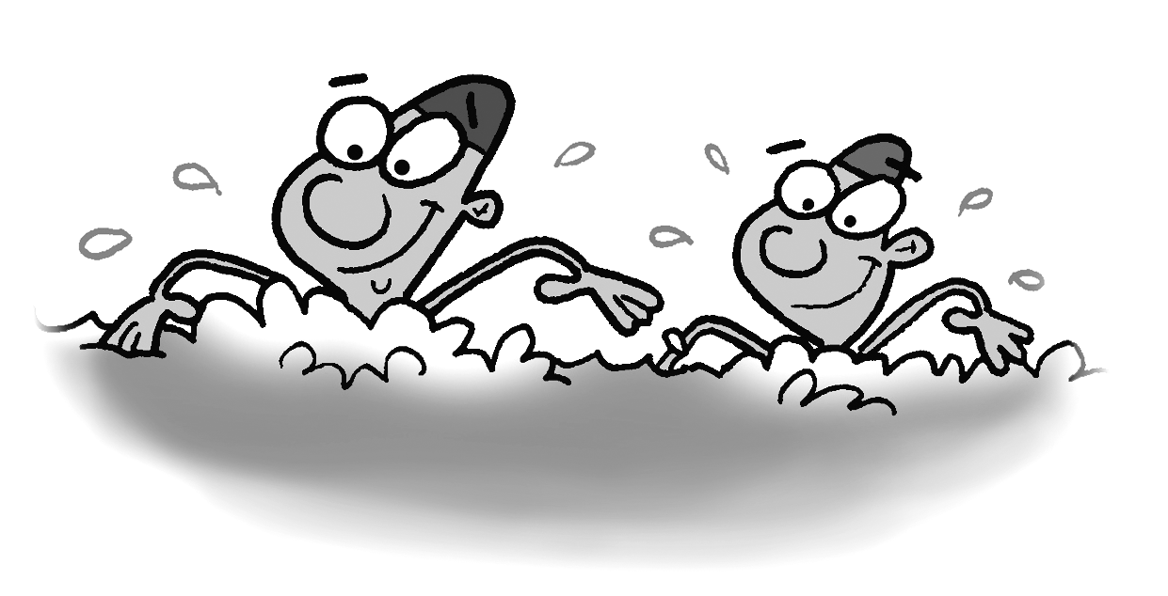
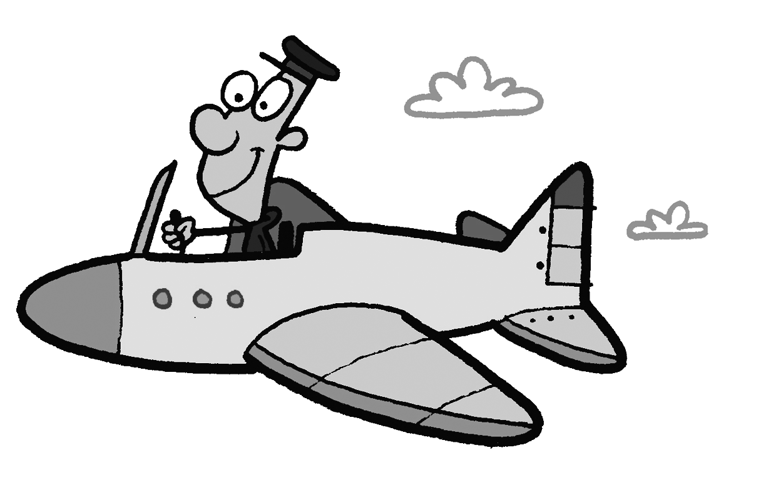
❸ They’re _____________ .

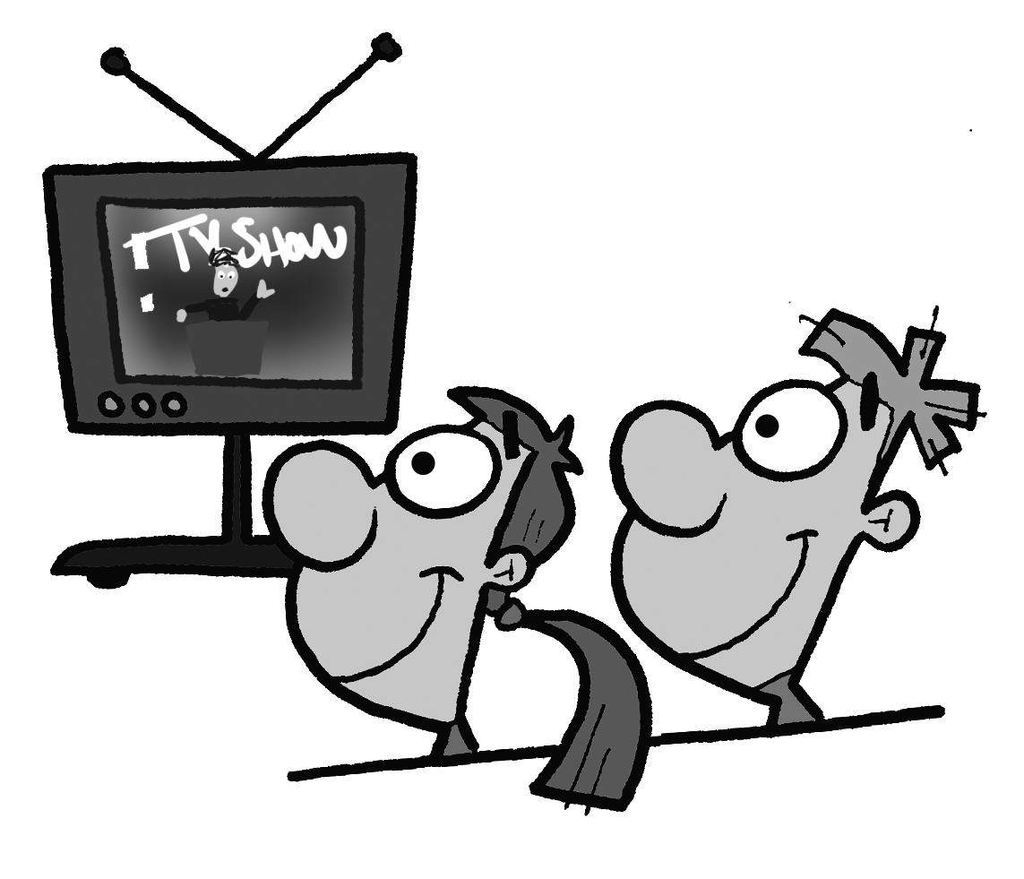
❹ He’s _____________ a plane.

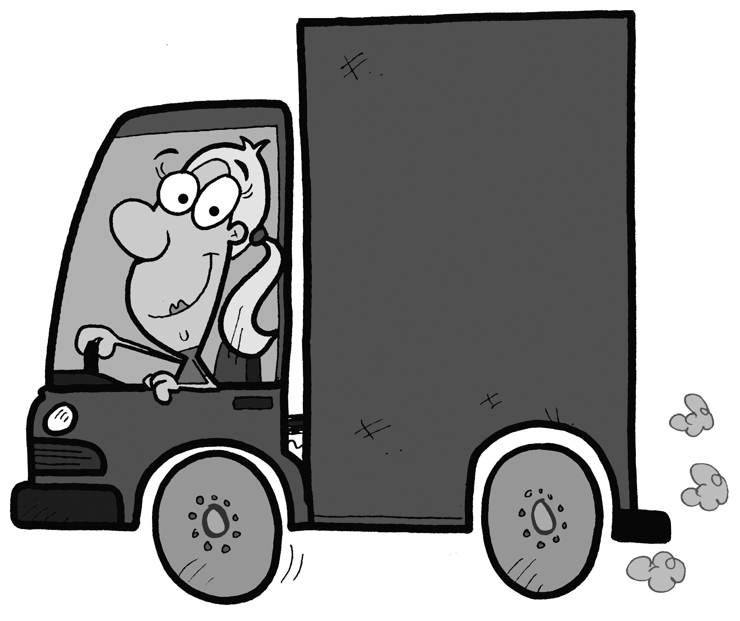
❺ They’re _____________ TV.

❻ She’s _____________ a lorry.

Total review mark / 15

