Name: | Class:

①Write the words. Mark / 5

❶ b ook 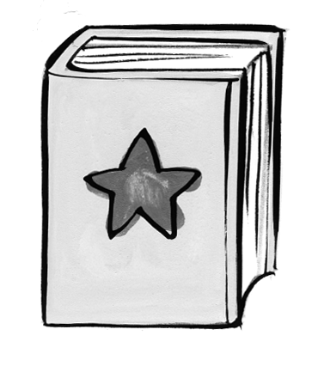 ❷ t _ ble 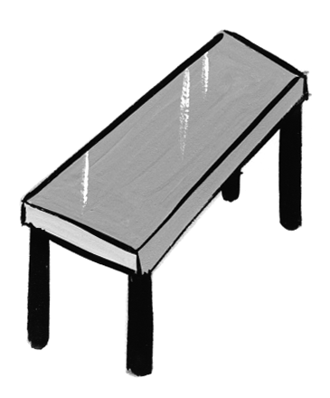

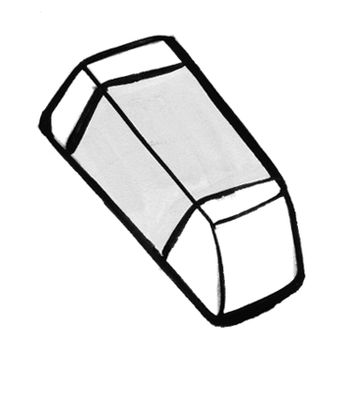
❸ _ en 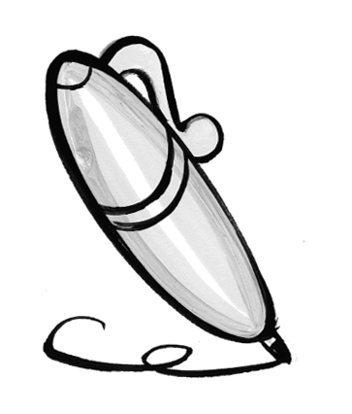 ❹ era _ er

❺ cha _ r 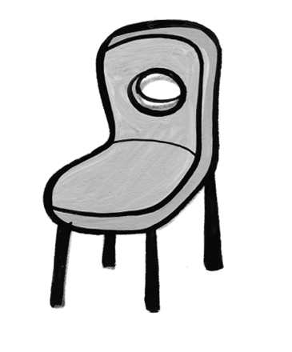 ❻ pen _ il 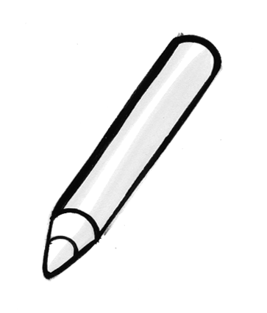


② Listen and match. Mark. / 5
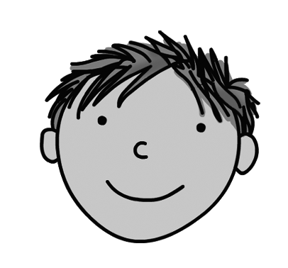
❶ Hello I’m fine, thank you.
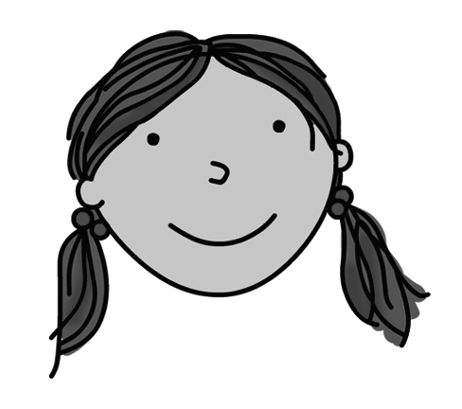
❷ What’s your name? Hello.

❸ Who’s that? I’m eight.

❹ Goodbye. Goodbye.

❺ How old are you? That’s Ben.

❻ How are you? I’m Sarah.

Total unit mark / 10

