Name: | Class:

①Match and write. Mark / 10

cat jacket nose tiger elephant horse socks
giraffe T shirt hippo teeth hair dog skirt

Pets | Face | Wild animals | Clothes
cat  ________  ________ | teeth  ________  ________ | elephant  ________  ________  ________ | T-shirt  ________  ________  ________


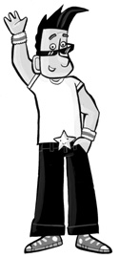
② Listen and number. Mark / 5

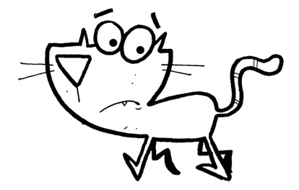
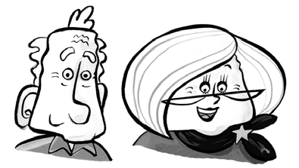



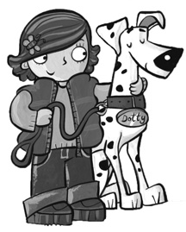
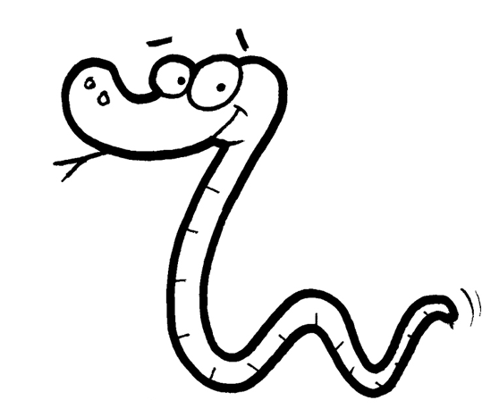
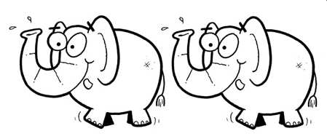

Total review mark / 15

