Name: | Class:
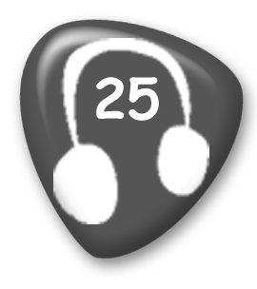
① Listen and number. Mark / 5
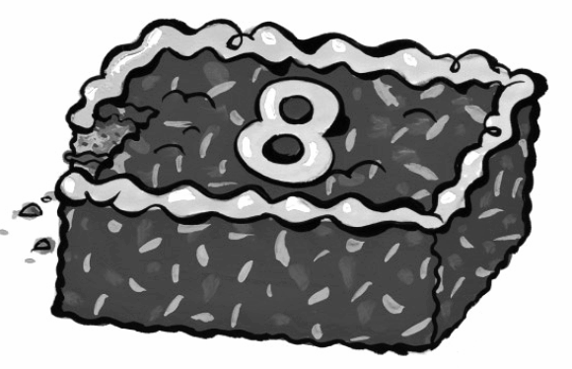
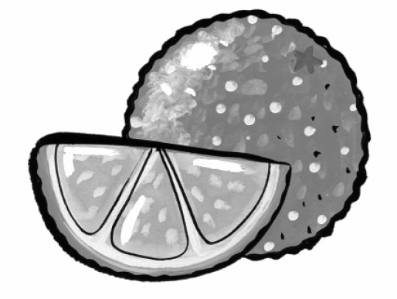
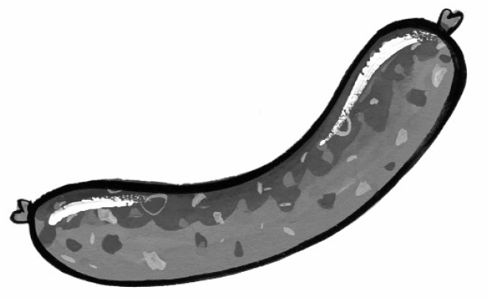
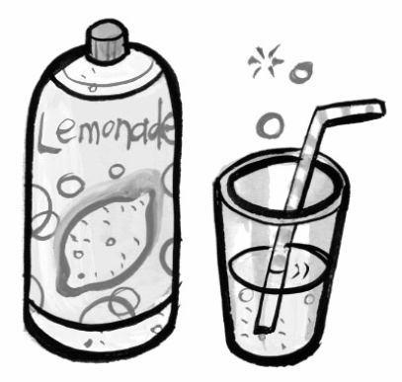
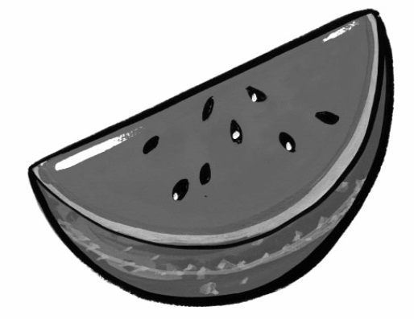
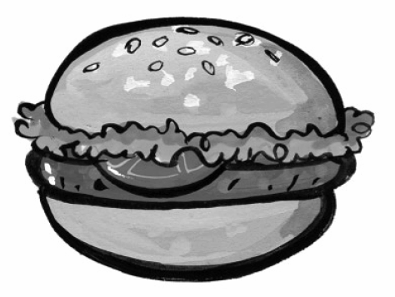




②Write the questions and answers. Mark / 5

❶ sausage? / a / Would / like / you
Would you like a sausage?

❷ I’d / Yes, / one. / love
____________________________________

❸ some / Can / lemonade? / have / I
____________________________________

❹ are. / you / Here
____________________________________

❺ some / Would / like / watermelon? / you
____________________________________

❻ you. / No / thank
____________________________________

<MARQUEE BEHAVIOR=\ Total unit mark / 10

