Name: | Class:

①Look and write. Mark / 5


11 18 14

eleven fifteen twenty _____ _____ twelve

②Read and circle. Mark. / 5
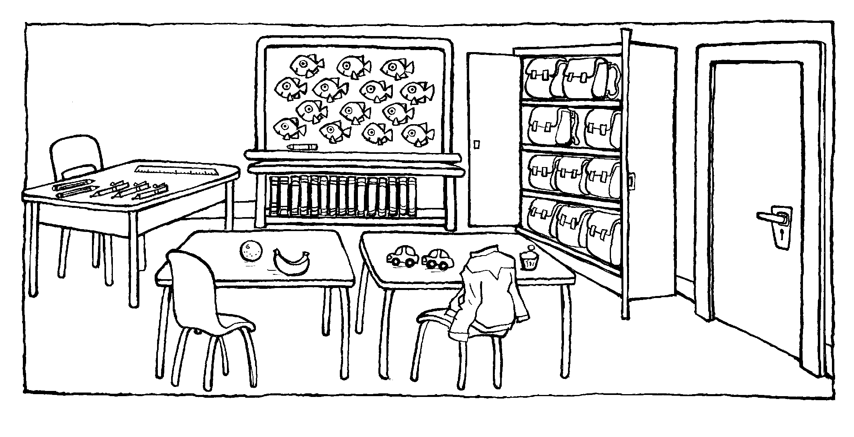

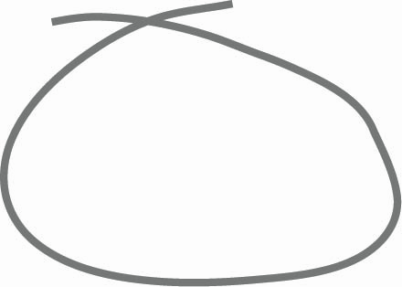


❶ There ‘s / are desks in the classroom.
❷ There is / are a cupboard in the classroom.
❸ There aren’t / isn’t a teacher in the classroom.
❹ There ‘s / are a whiteboard in the classroom.
❺ There ’s / are a ruler in the classroom.
❻ There ‘s / are a bookcase in the classroom.

Total unit mark / 10

