Name: | Class:

①Write the words. Mark / 5
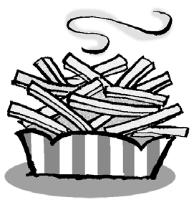
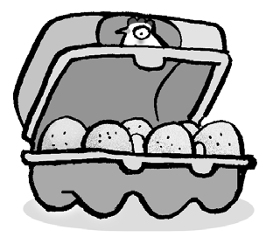
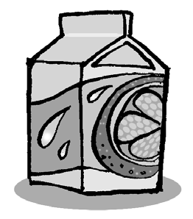
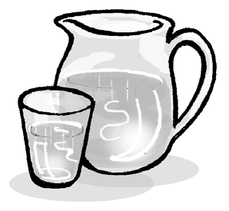
❶ c h i p s ❷ _ g _ _

❸ w _ _ _ _ ❹ _ u _ _ _
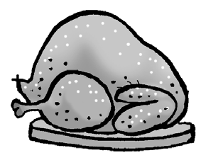
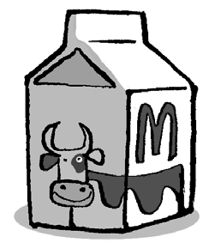
❺ _ h _ _ _ e n ❻ m _ _ _

②Order and write. Mark / 5

❶ chips, /please? /some / have / I / Can
Can I have some chips, please?

❷ Can / have / some / I / chicken, / please?
____________________________________

❸ his / What’s / breakfast? / favourite
____________________________________

❹ an / please? / egg, / have / I / Can
____________________________________

❺ please? / have / I / rice, / Can / some
____________________________________

❻ favourite / bananas. / breakfast / His / is
____________________________________

Total unit mark / 10

