Name: | Class:

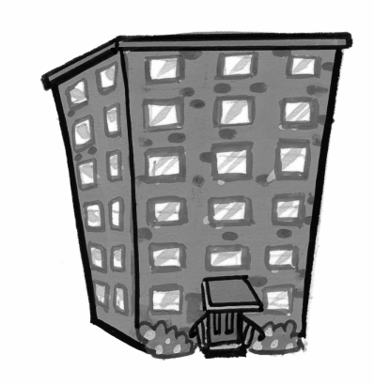
①Match. Mark / 5
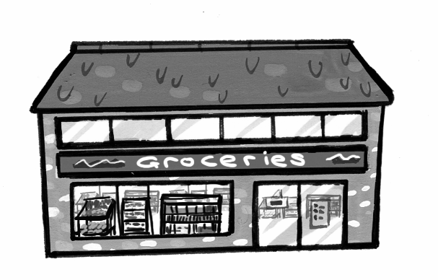
flat

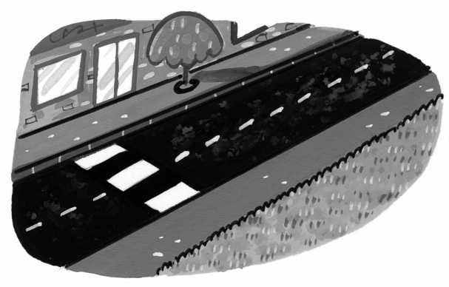
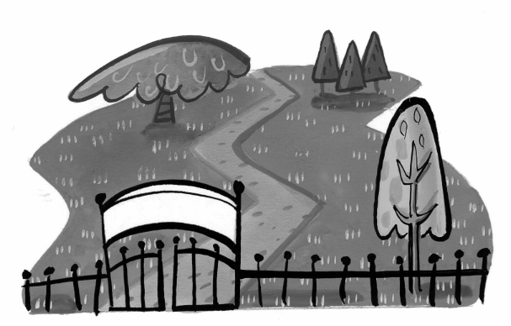
shop

park

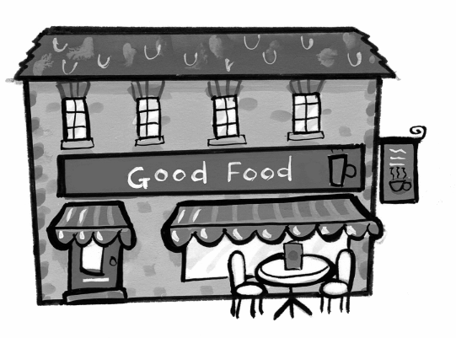
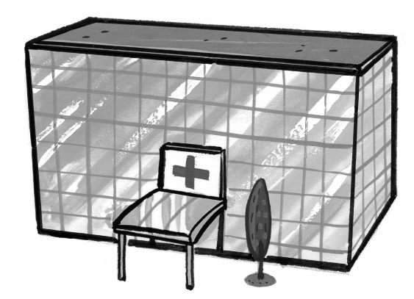
street

café

hospital

②Look and tick () or cross (). Mark / 5
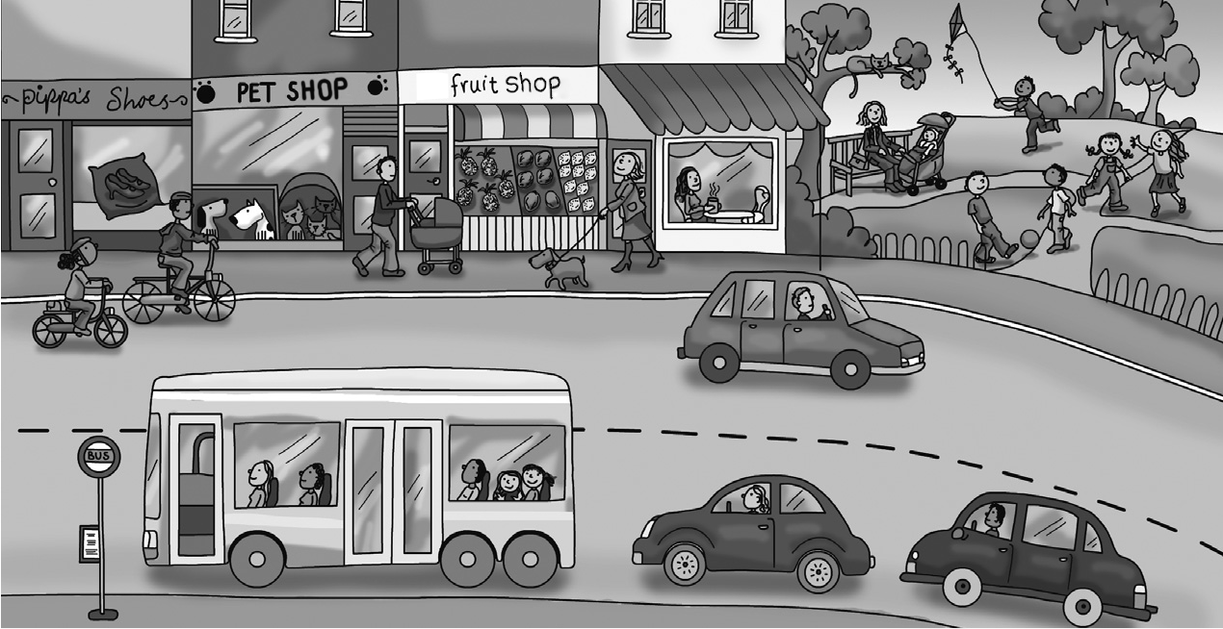

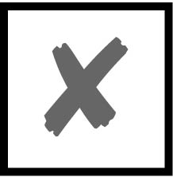

❶ There are ten shops.

❷ The café is next to the park.

❸ The fruit shop is between the pet shop and the shoe shop.
❹ There are two cars behind the bus.

❺ The dog is in front of the fruit shop.

❻ There are three bikes.
Total unit mark / 10

