Name: | Class:

①Write the questions and answers. Mark /10

❶ picking / shells? / Does / up / Suzy / like
Does Suzy like picking up shells?
❷ does. / she / Yes,
________________
❸ Do / like / beach? / you / going / the / to
____________________________________
❹ do. / I / Yes,
____________________________________
❺ fishing? / Rick / Does / like
____________________________________
❻ doesn’t. / No, / he
____________________________________

②Look and write. Mark / 5

him her you us them me

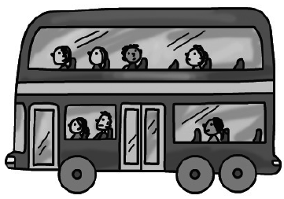
❶ Look at her. ❷ Look at _________.
She’s wearing a skirt. We’re on the bus.
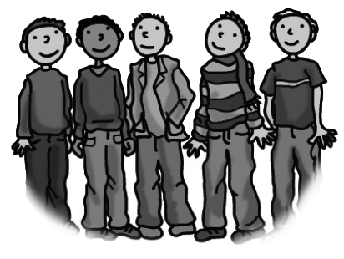
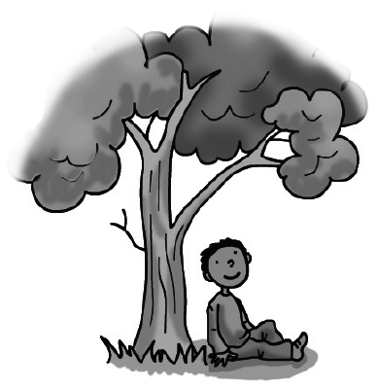
❸ Look at _________. ❹ Look at _________.
I’m under a tree. Look at those men.
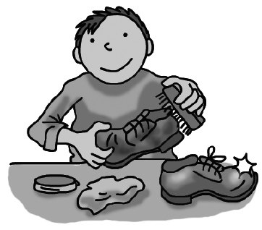
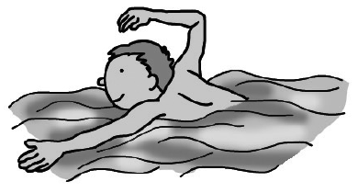
❺ Look at _________. ❻ Look at _________.
He can swim. You’re cleaning a shoe.

Total review mark / 15

