Name: | Class:

①Circle the odd one out. Mark / 5
❶ | cartoon | documentary | news | 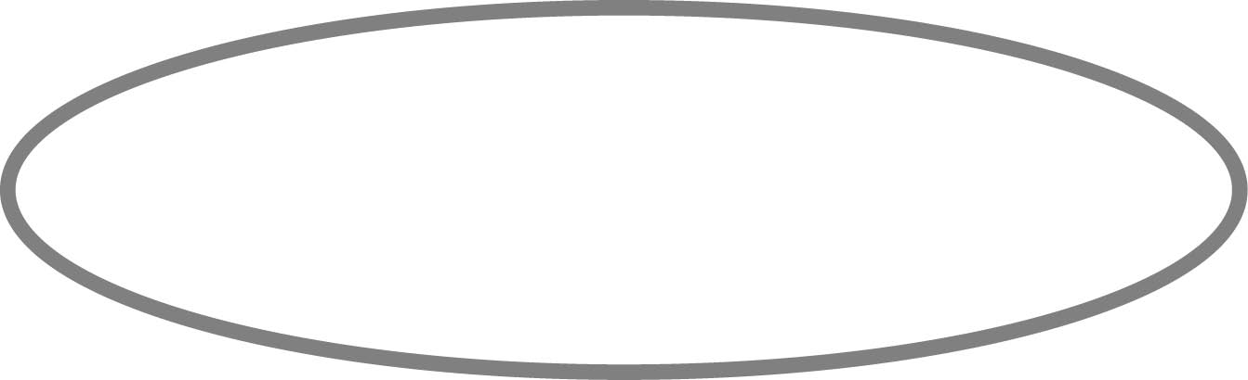  funny | quiz
❷ | exciting | boring | good | job | interesting
❸ | milk teeth | hairbrush | molar | chew | gum
❹ | half past | quarter to | o’clock | quarter past | clock
❺ | thief | commentator | writer | driver | actor
❻ | programme | cinema | turn on | watch | channel

②Look at the pictures, read and write. Mark / 10

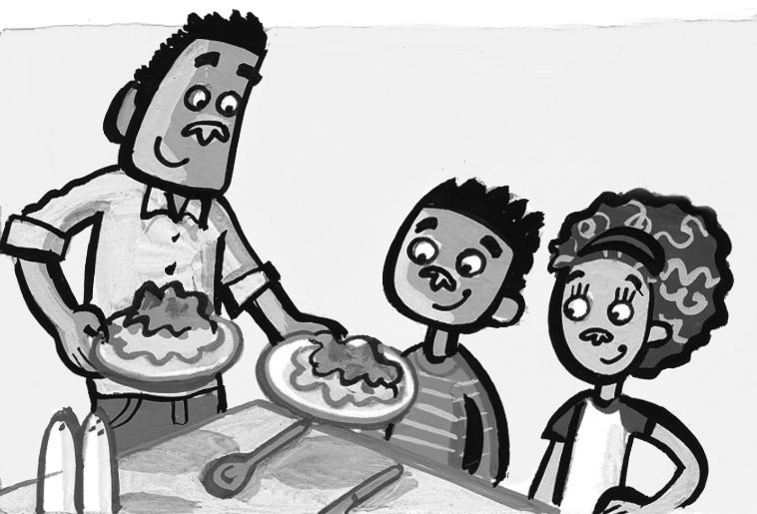
have lunch skate buy a computer
brush her teeth play football sleep
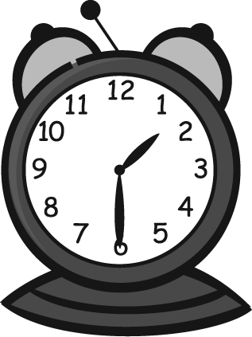
❶ They’re going to have lunch at half past one.

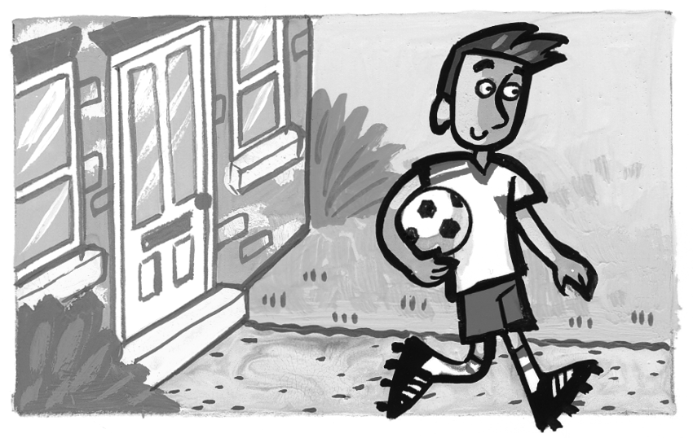
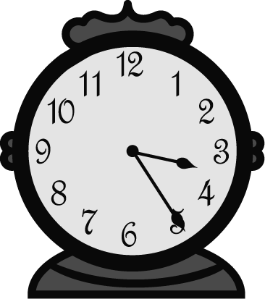
❷ ______________________

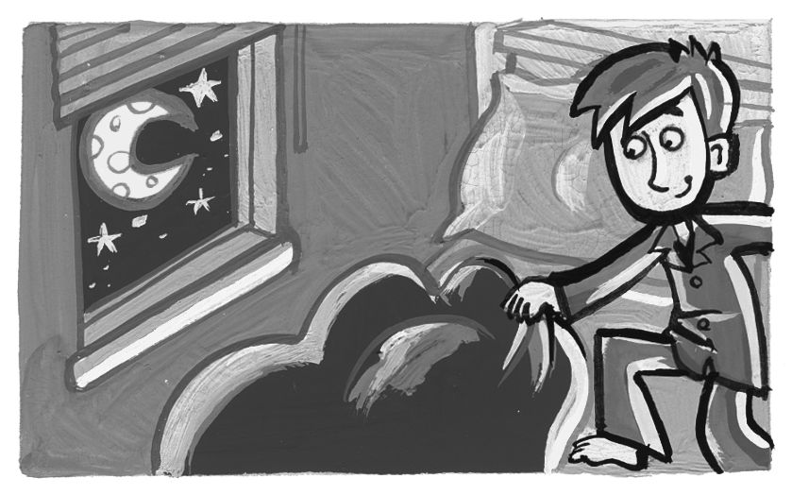
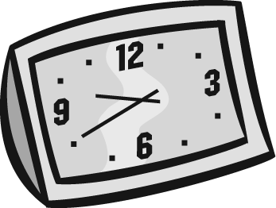
❸ ______________________

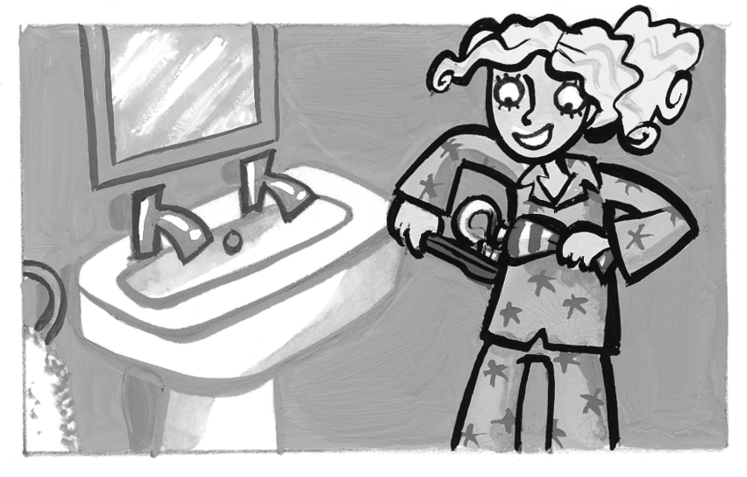
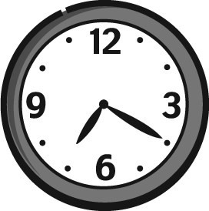
❹ ______________________

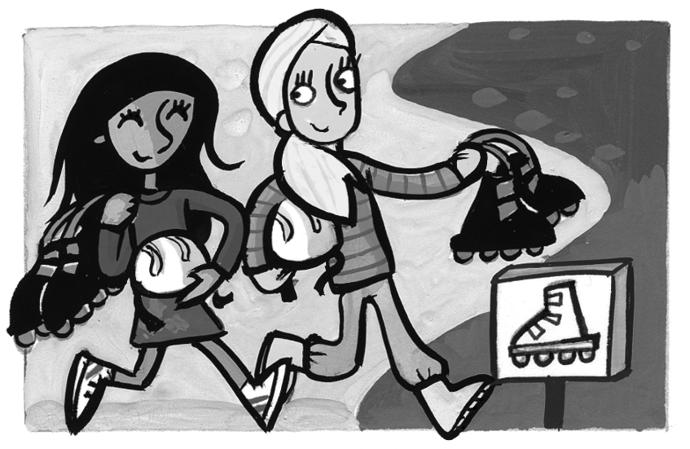
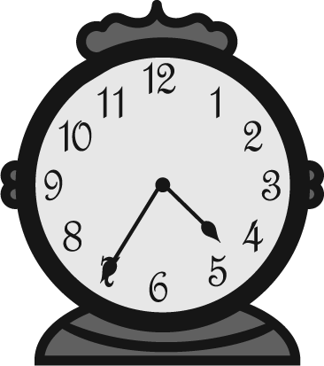
❺ ______________________

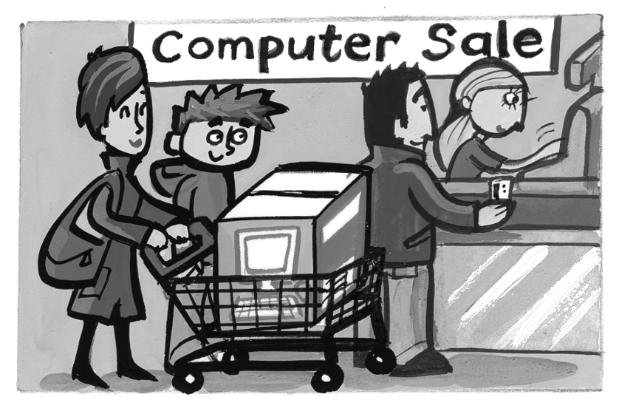
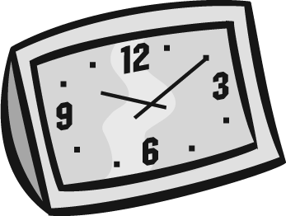
❻ ______________________

Total review mark / 15

