Name: | Class:

① Listen and circle. Mark / 5

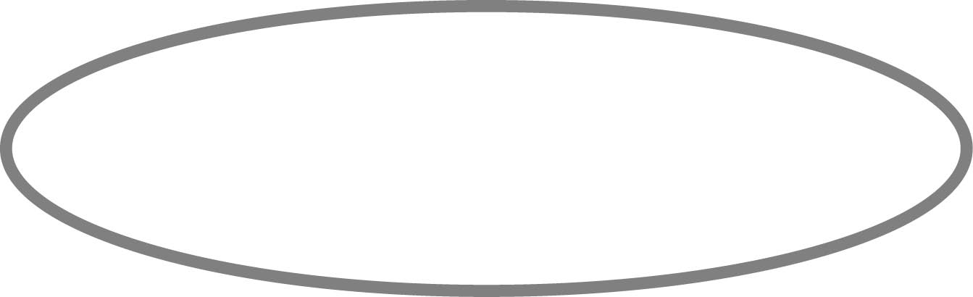
❶ Lucy had a good / bad day in the city yesterday.
❷ Lucy went to the city museum / park.
❸ Lucy skated with her sister in the morning / afternoon.
❹ Lucy had something to eat in the park / went to a restaurant.
❺ Lucy walked / went by taxi to the shops.
❻ Lucy wants to go / went to the theatre.

②Look at the map, read and write. Mark / 10

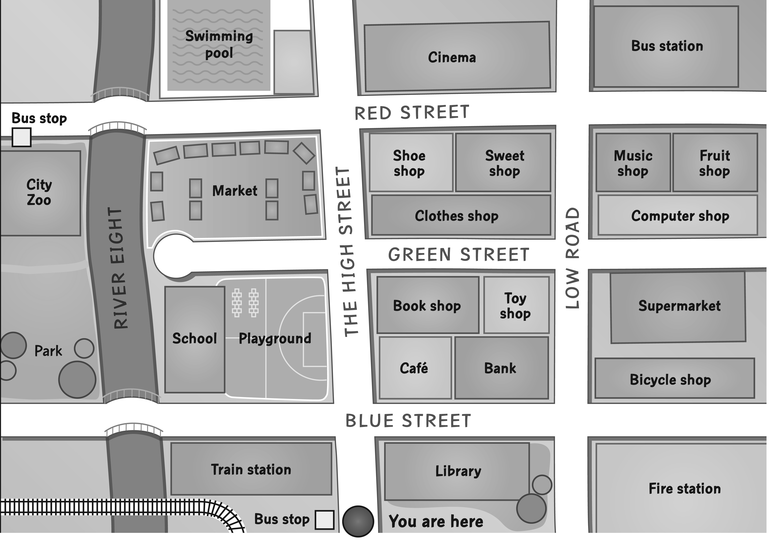
❶ Go straight on and take the third street on the
right. What’s on the left at the end of the
street? bus station

❷ Go along The High Street and turn right into
Green Street. Walk past the bookshop.
What’s next to it? __________

❸ Go straight on and turn left after the market.
What’s opposite it? __________

❹ Take the first street on the left and cross over the bridge.
What’s on the right? __________

❺ Go straight on, turn right into Red Street and stop.
What’s on the corner next to the sweet shop? __________

❻ Go along The High Street and take the third street on the left.
Go straight on past the market and over the river.
What’s outside the zoo? __________

Total unit mark / 15

