Name: | Class:

①Read and match. Mark / 5

❶ Was he playing in the classroom when her mum arrived home.
❷ When we were sailing to the island, when I cut my foot.
❸ I was swimming in the sea when he broke the chair?
❹ When you were travelling in Italy, our boat hit an iceberg.
❺ She wasn’t doing her homework did you visit Rome?
❻ Did it start to rain when they were having a picnic?

②Read and complete. Mark / 10

❶ A dangerous thing which
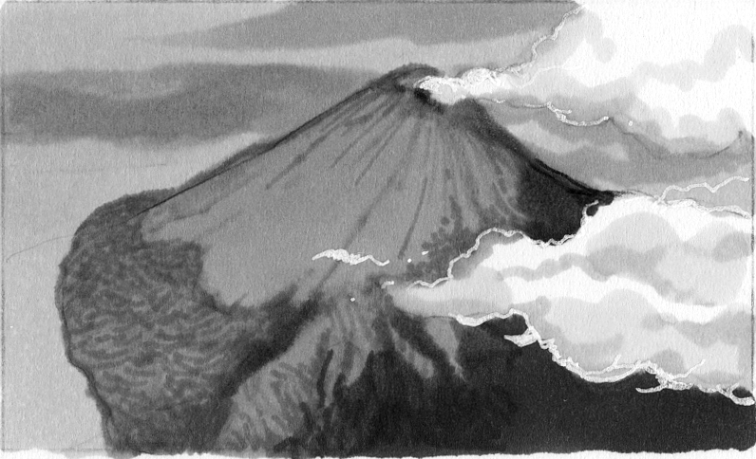
volcanoes do. erupt

❷ A person who stops a fire. ______

❸ The month between January
and March. ______

❹ A disaster after there is an
earthquake under water. ______

❺ A direction where you can go if you don’t turn left or right. ______

❻ A place where you can borrow books. ______

❼ A place in the city where you can go for help. ______

❽ A place which has water around it. ______

❾ A cloud which is near the ground and stops you seeing well. ______

❿ A place where you can catch a bus. ______


A place where you can go for dinner. ______

Total review mark / 15

