Name: | Class:

①Read and choose the best answer. Mark / 5

a Yes, I did every exercise. b I’m sorry, you can’t.
c Yes, I know I took it home. d Not really!
e I’m sorry! I had a disaster this morning. f I couldn’t find my schoolbag.

Teacher: Late again Emma? ❷ Emma: _ I think my brother moved
❶ Emma: e it when I was having a shower.
Teacher: What happened? Teacher: Did you take your bag home?

❸ Emma: _ My bag was in my ❹ Emma: _ When I was doing it I was
room when I was doing listening to music.
my homework. Teacher: Oh, I see. Did you finish your
Teacher: Was it difficult? homework?

❺ Emma: _ ❻ Emma: _ My homework is in my
Teacher: Can I have your schoolbag!

homework, please?

② Listen and tick () the box. Mark / 10

❶ What was Ali doing when he ❷ What was the weather like
hurt his leg? when they were driving home?
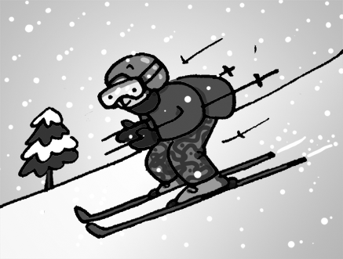
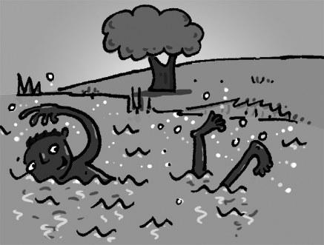
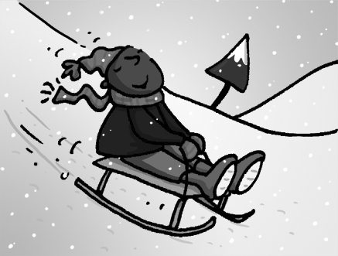
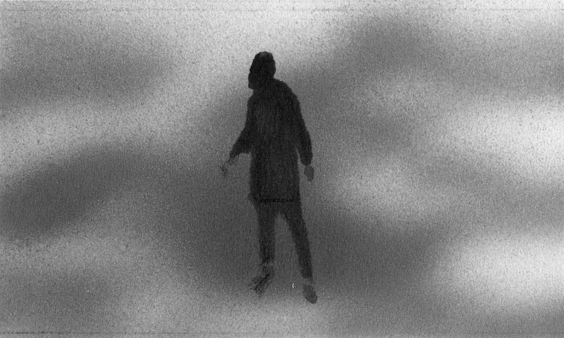
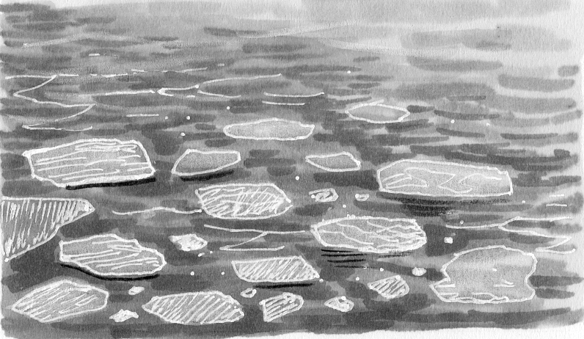
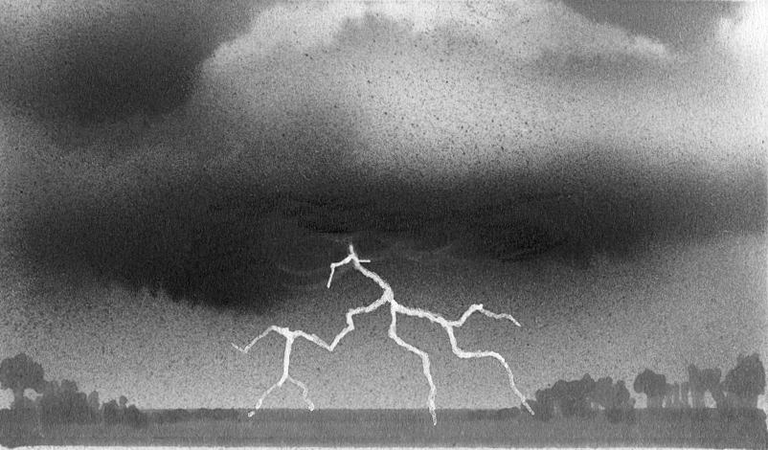

a b c a b c


❸ When is Anna going to have ❹ What was Sam doing at 2 o’clock
a holiday? yesterday afternoon?
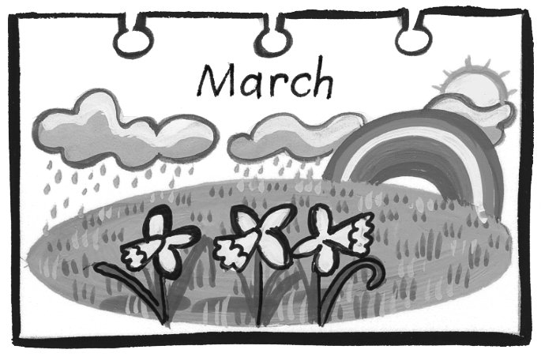
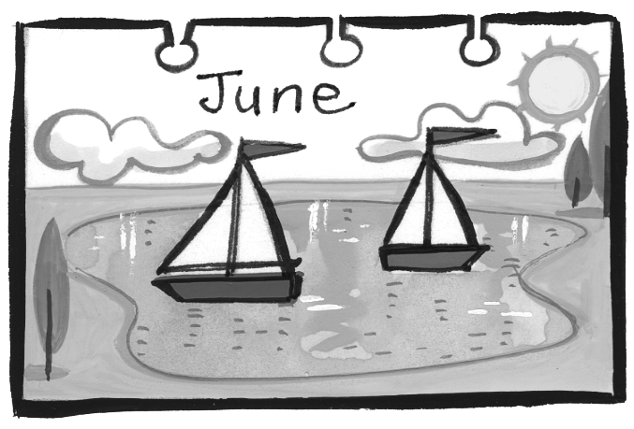
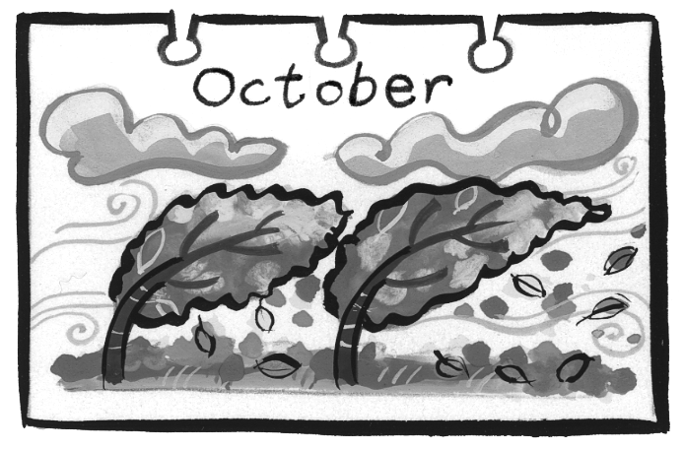
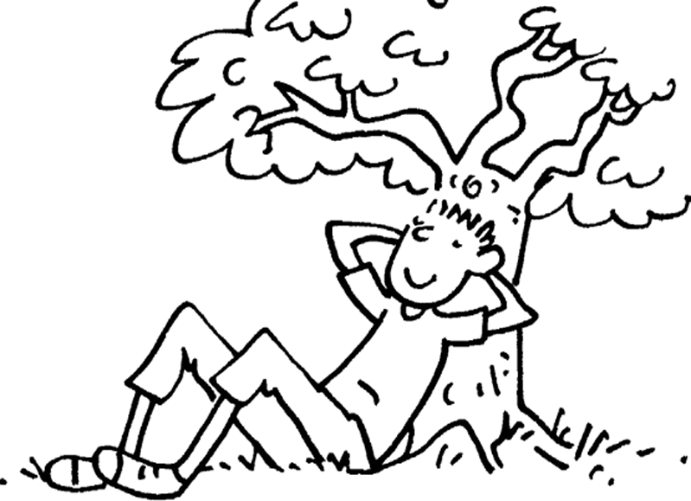
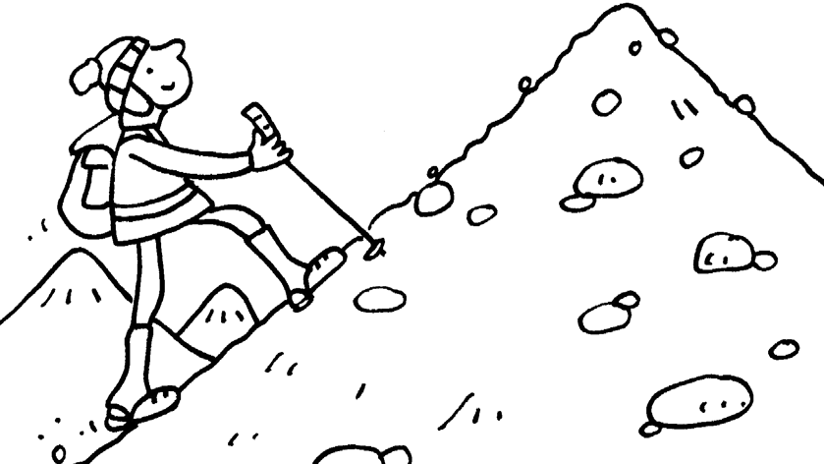
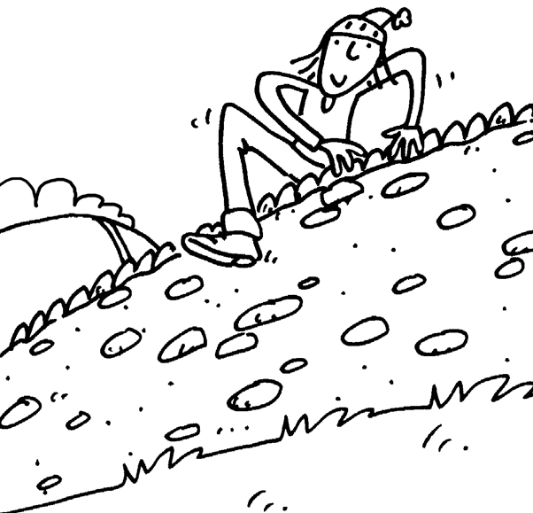
a b c a b c

❺ What disaster did Ed hear ❻ What was Paul doing at half
about on the news? past four?
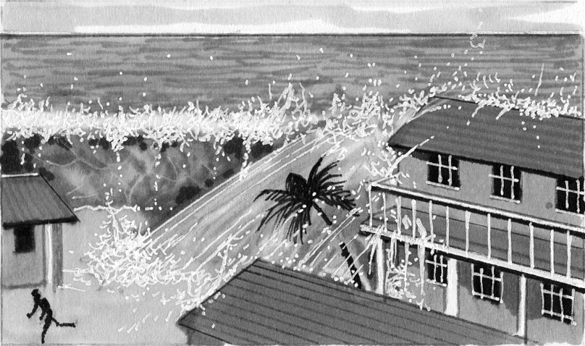
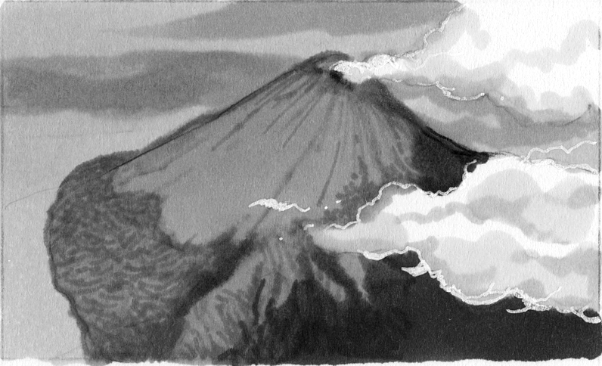
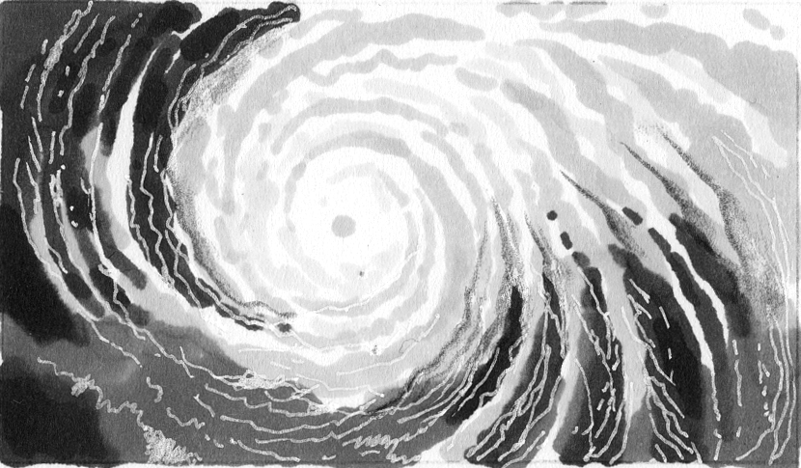
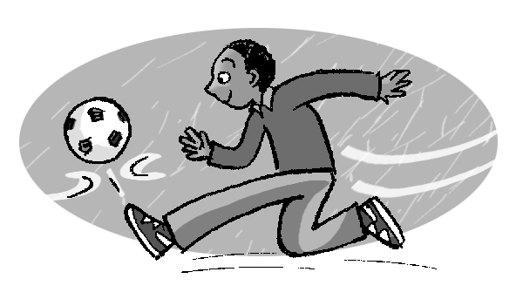
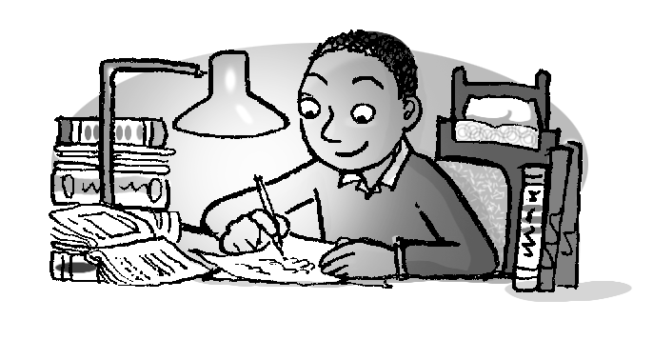
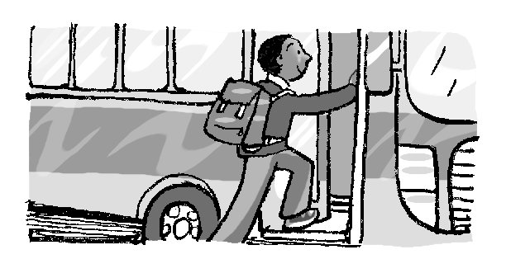
a b c a b c

Total unit mark / 15

