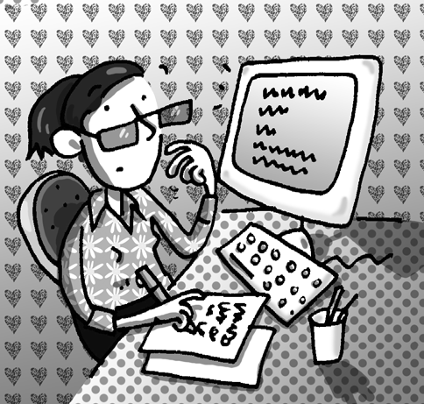
Name: | Class:

①Read and match. Mark / 5

❶ You shouldn’t go into a field she’s won the competition.

❷ She’s so happy because been ice-skating?

❸ When the sun is strong which has a bull in it.

❹ The teacher’s angry you should wear a hat.

❺ Have you ever cleaned the bathroom this week.

❻ They haven’t because her students haven't
done their homework.

② Listen and tick (). Mark / 10

 | 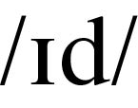 | 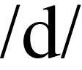
❶ He’s climbed the mountain. |  | 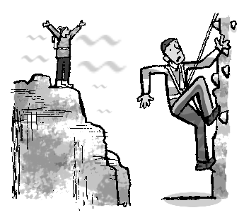  
❷ We wanted to eat salad.
❸ She used a computer.
❹ Some frogs are spotted.
❺ He started his homework.
❻ Pandas are endangered.
❼ Have they cleaned the car?

Total unit mark / 15

