Name: | Class:

①Read and tick () the correct sentences. Mark / 5
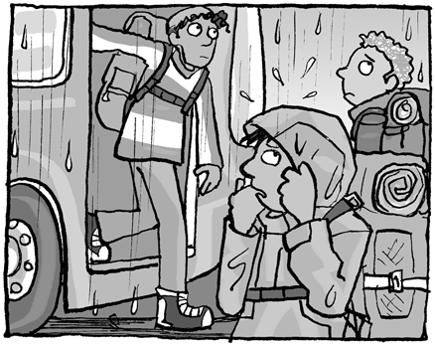
❶ a When they arrived, it rained.

b When they arrived, it was raining.
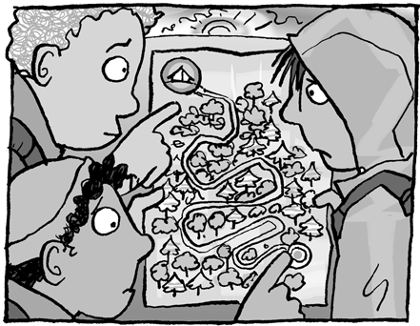
❷ a They were looking for a campsite on the map.
b They was looking for a campsite on the map.
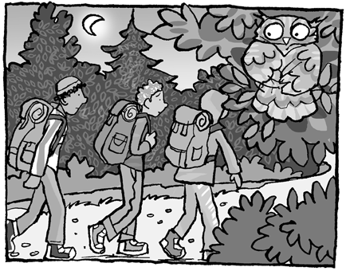
❸ a It was got late when they were walking.
b It was getting late when they were walking.

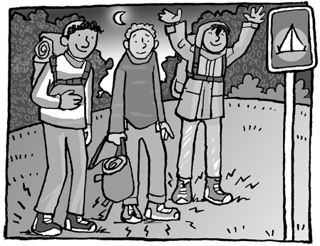
❹ a Their feet was hurting after the long walk.
b Their feet were hurting after the long walk.
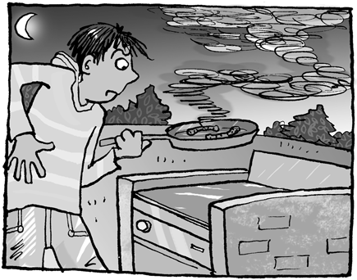
❺ a He was cooking the sausages well.
b He was cooking the sausages badly.
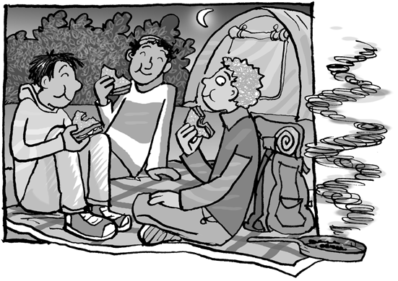
❻ a They were chatting and eating sandwiches.
b They were chatted and ate sandwiches.

②Read and complete. Mark / 10
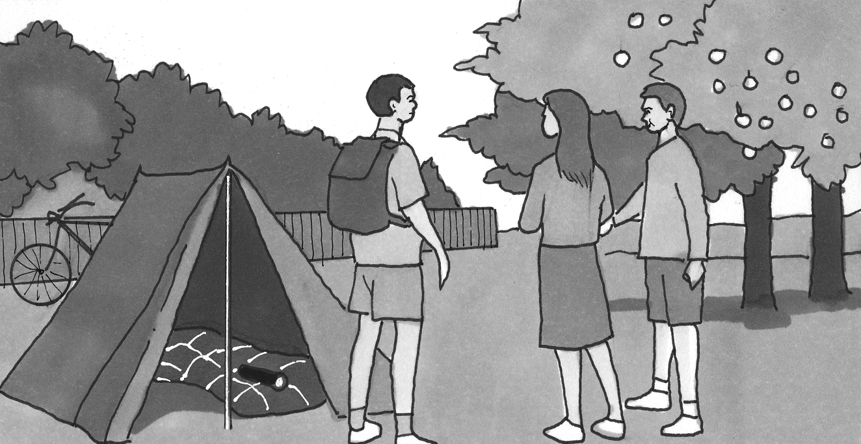
❶ The boy wearing a T-shirt is
going to camp.
T-shirt jumper skirt
❷ There is a _______ on the sleeping bag.
umbrella sign torch
❸ The boy on the left has got a __________.
suitcase rucksack handbag
❹ One boy is going to __________ in the tent.
study sleep run
❺ There is a bike __________ the tent.
next to between behind
❻ The tent is in the __________.
city countryside town

Total unit mark / 15

