Name: | Class:

①Read and write yes or no. Mark / 10

❶ They are going to have breakfast. no
❷ There aren’t enough cakes. __
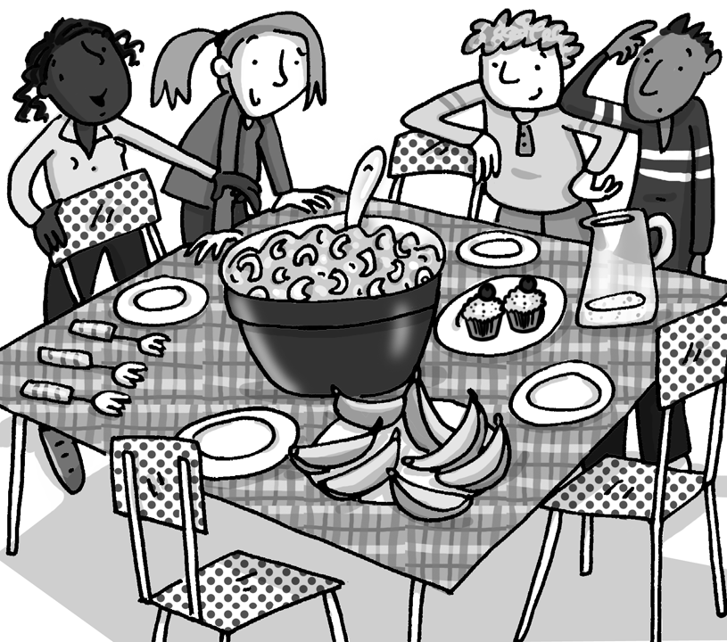
❸ They are going to eat with chopsticks. __
❹ There is too much sushi in the big bowl. __
❺ There isn’t enough water. __
❻ There are too many bananas. __
❼ There is too much jam. __
❽ They haven’t got any plates. __
❾ All the things on the table are snacks. __
There are enough cups for the water. __

They aren’t sitting down. __
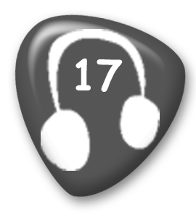
② Listen and number. Mark / 5

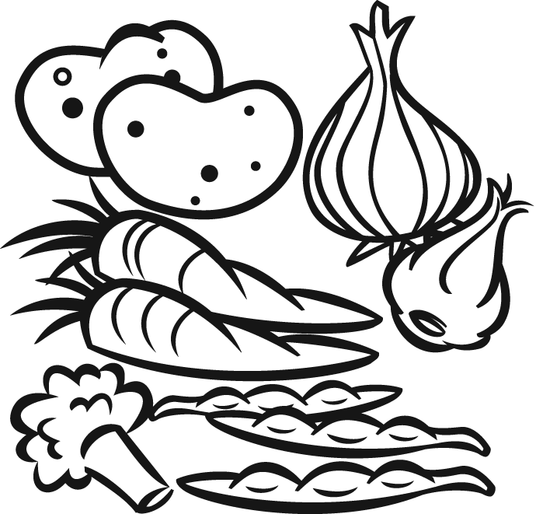
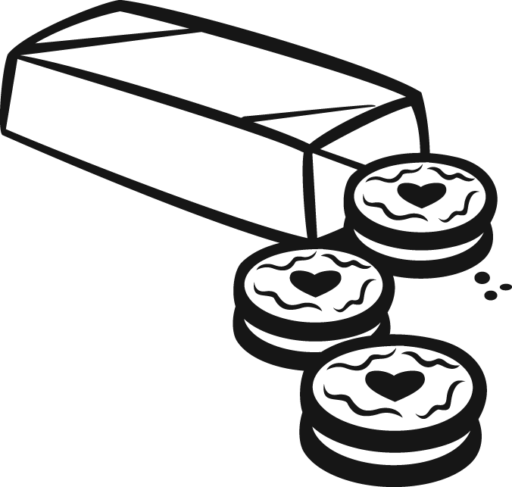
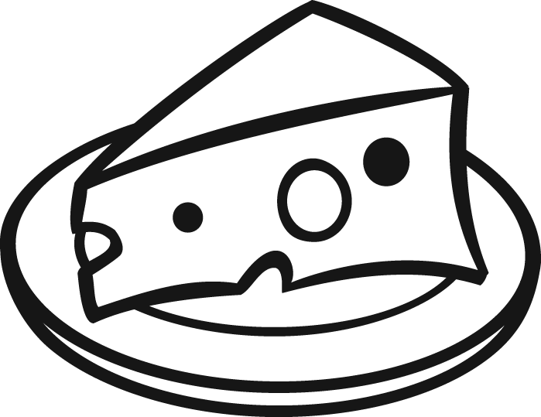

__ __ __
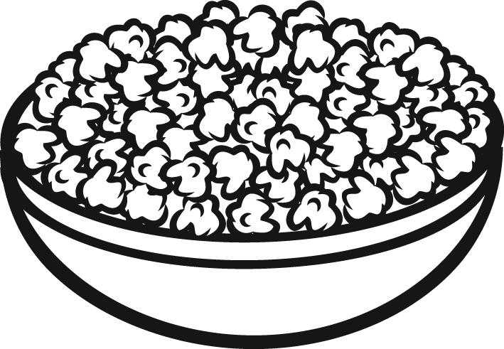
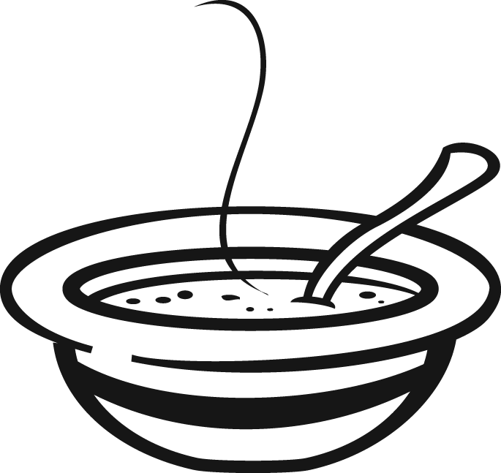
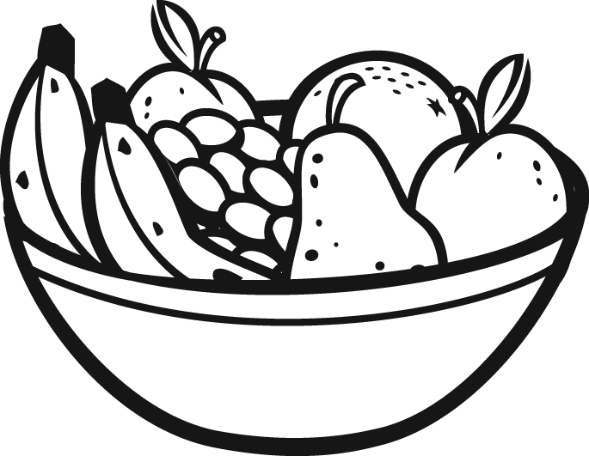

__ __ 1

Total unit mark / 15

