Name: | Class:

①Read and tick () or cross (). Mark / 5

❶ Everyone is doing something different.

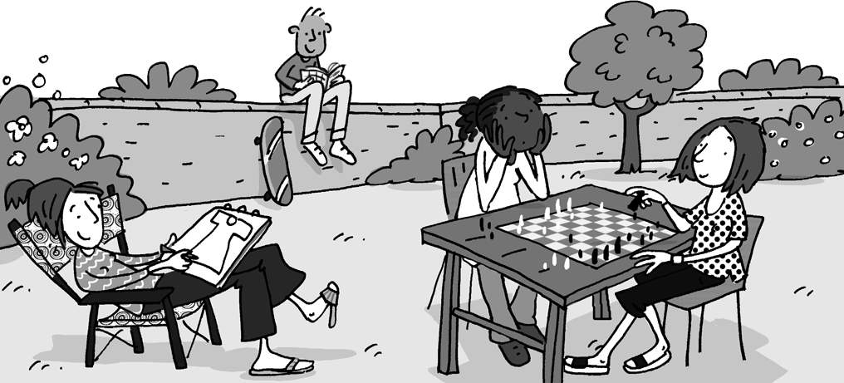
❷ The boy isn’t doing anything.
❸ They are somewhat quiet.
❹ There isn’t anyone sitting on the wall.
❺ No one is playing tennis.
❻ Everyone is sitting down.

②Read and match. Mark / 10

❶ ❷ ❸ ❹ ❺ ❻
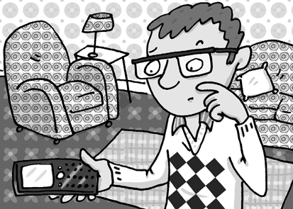
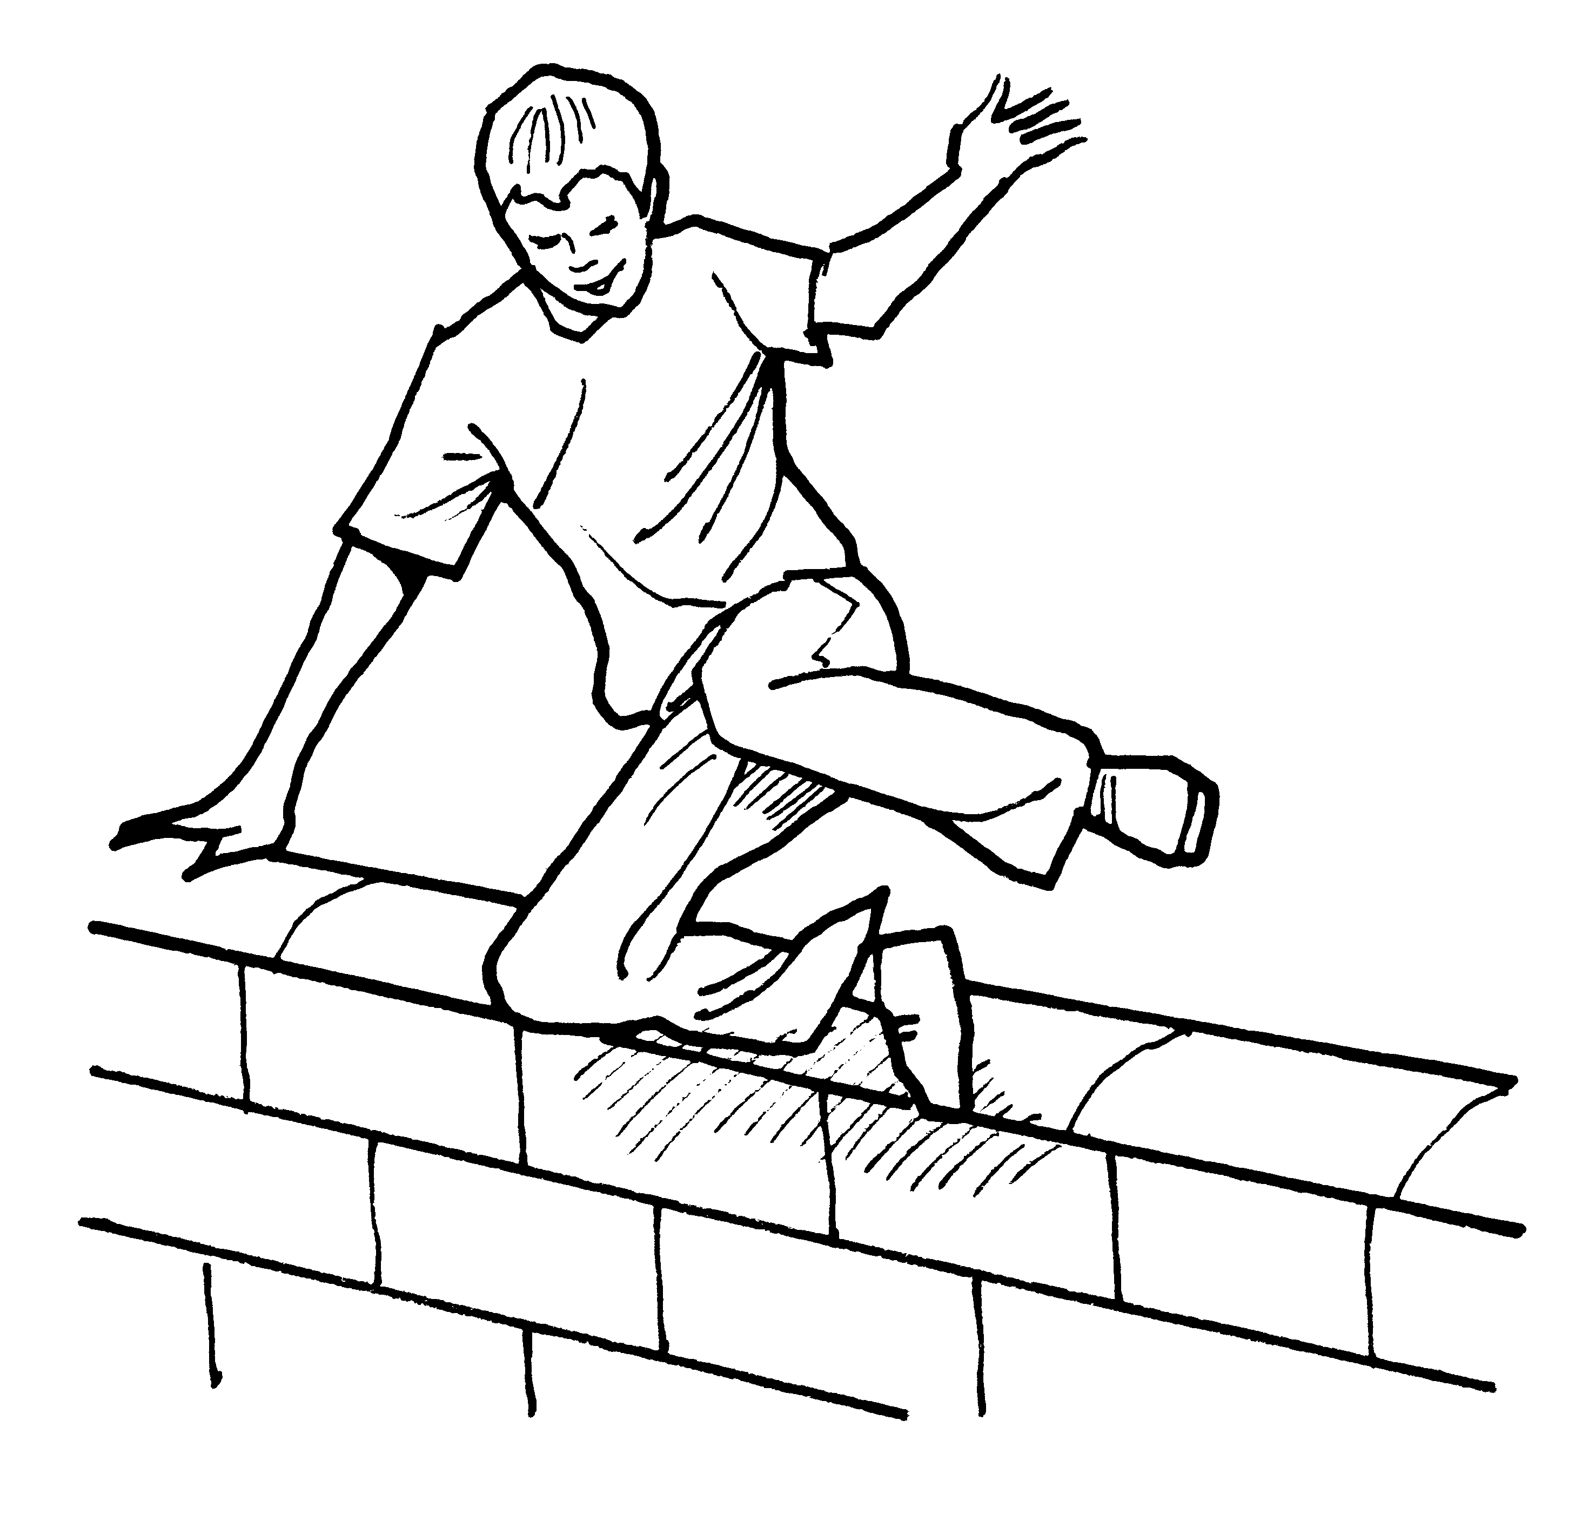
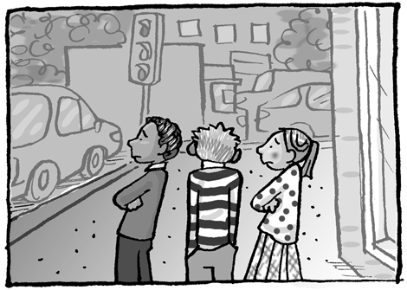
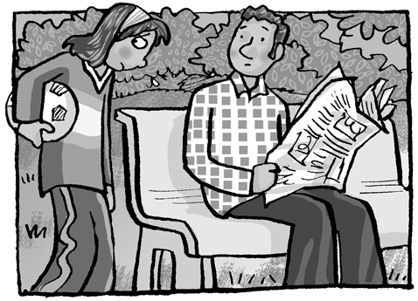
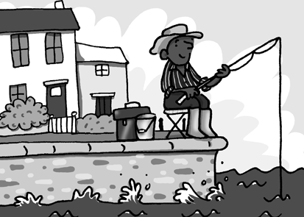
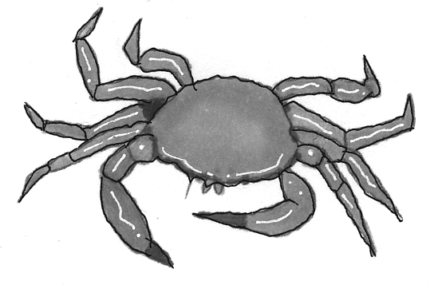

❶ His friend | anything | for millions of years.
❷ Crabs have | free running | fishing with him.
❸ They haven’t got | still hasn’t | called him.
❹ She hasn’t got | anyone | to play football with.
❺ No one | lived | since he was thirteen.
❻ He’s done | has gone | to do.

Total review mark / 15

