Name: | Class:

①Complete the table. Mark / 10

ten o’clock three hours six years 21st April 2011
Tuesday four months this morning years Sunday two weeks
for | since
______________________  ______________________  ______________________  ______________________  ______________________  ______________________ | ten o’clock  ______________________  ______________________  ______________________  ______________________  ______________________

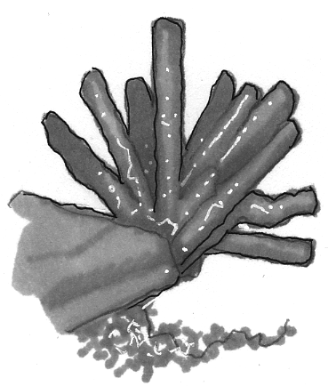
②Read and tick () or cross (). Mark / 5

❶ Coral reefs look like forests.

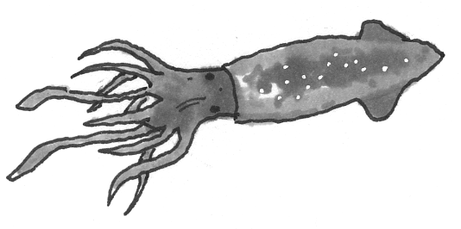
❷ A squid has got seven legs.
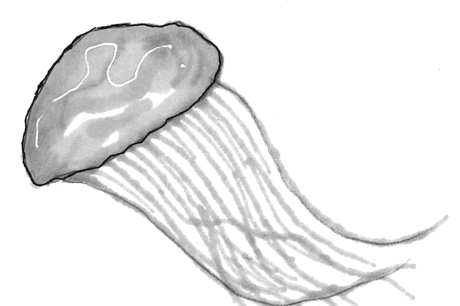
❸ Jellyfish haven’t got brains or bones.
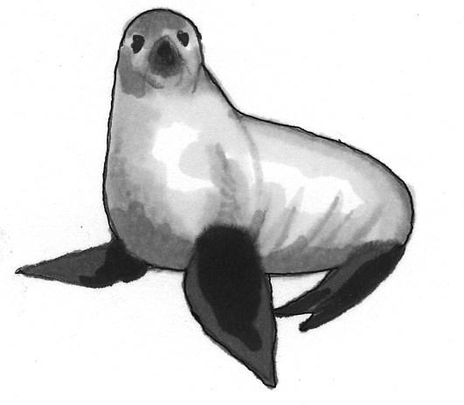
❹ Seals lay eggs.
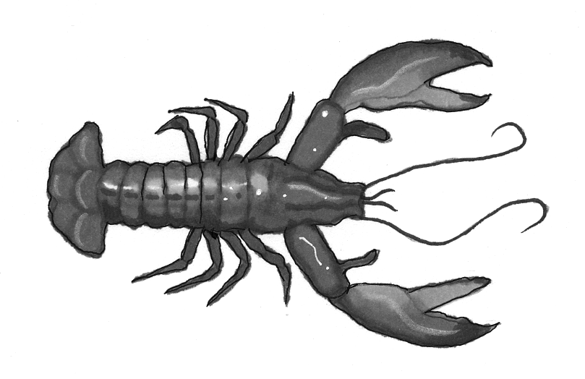
❺ Lobsters have got a hard shell.
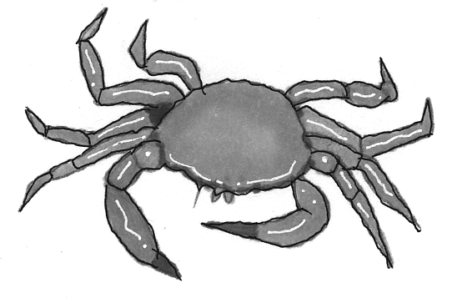
❻ Crabs haven’t got claws.

Total unit mark / 15

