Name: | Class:
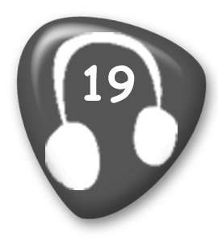
① Listen and number. Mark / 5
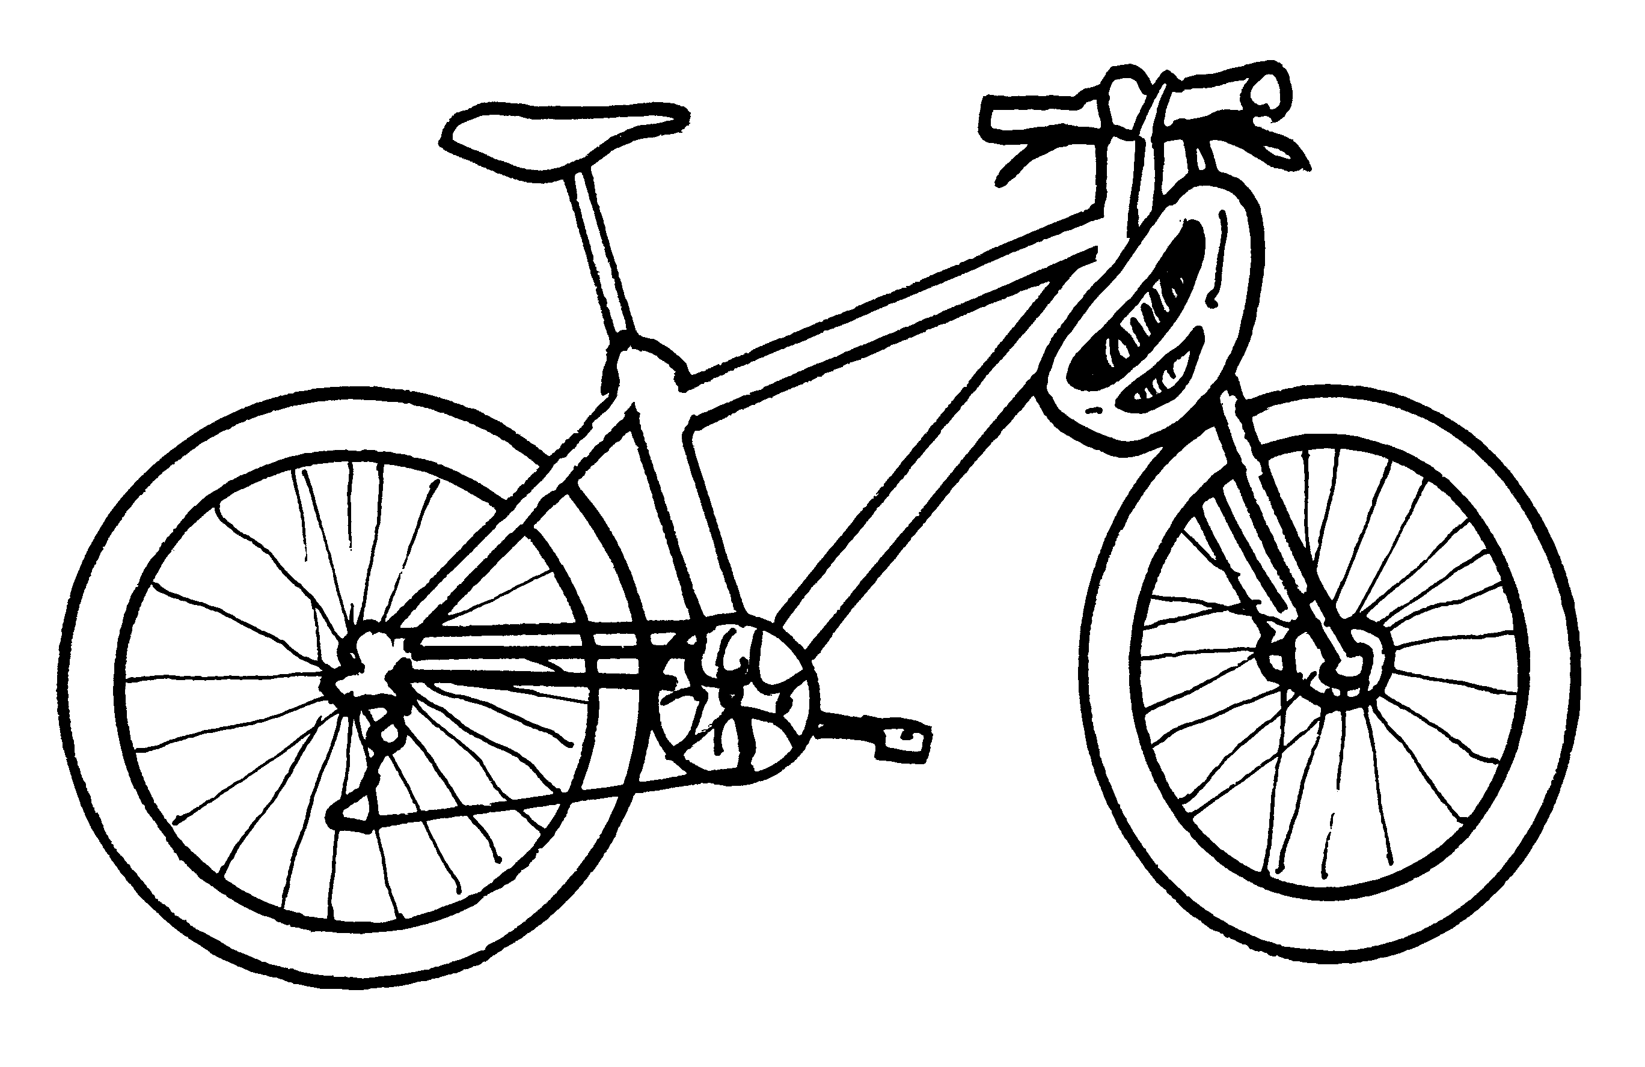
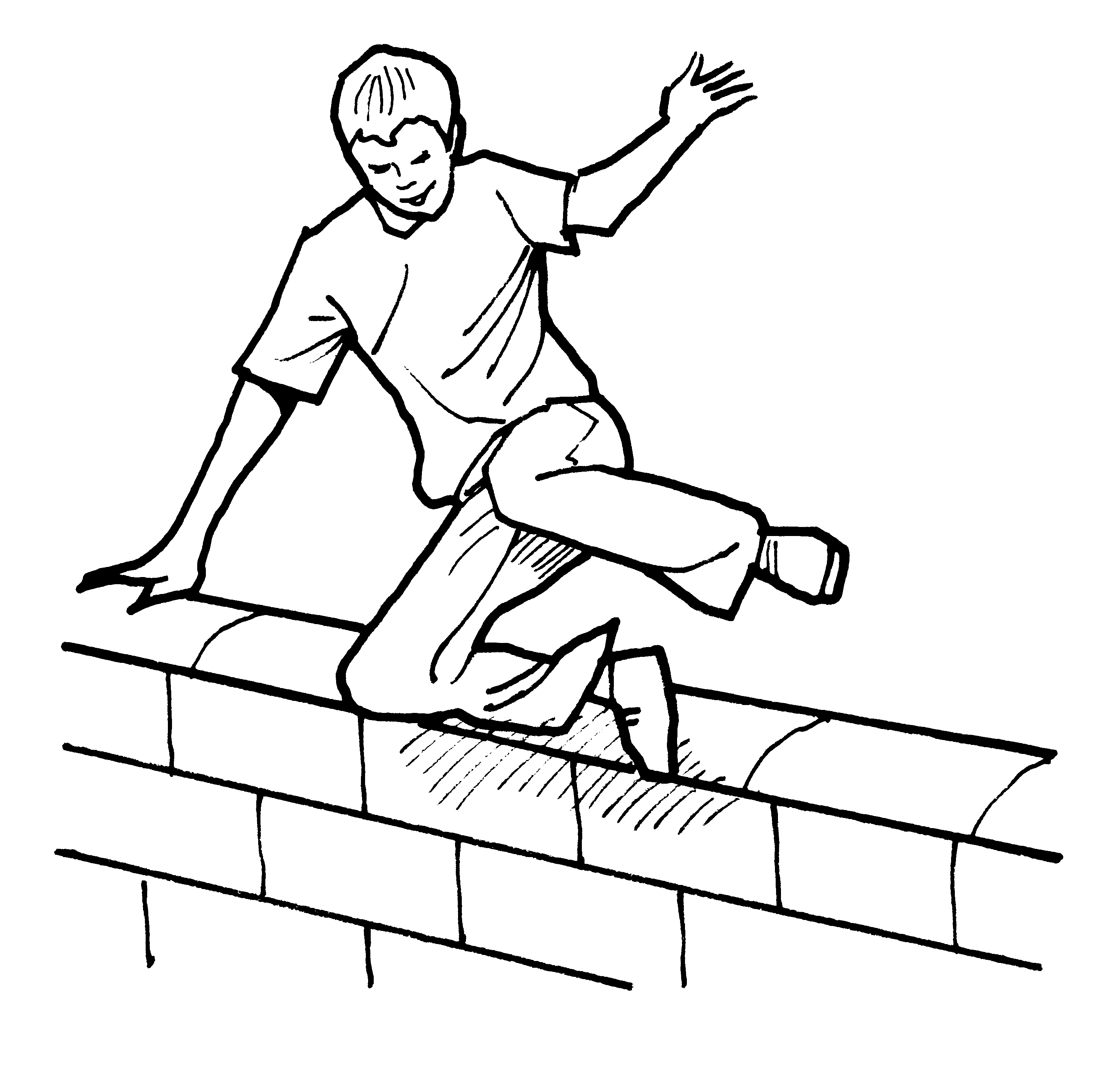
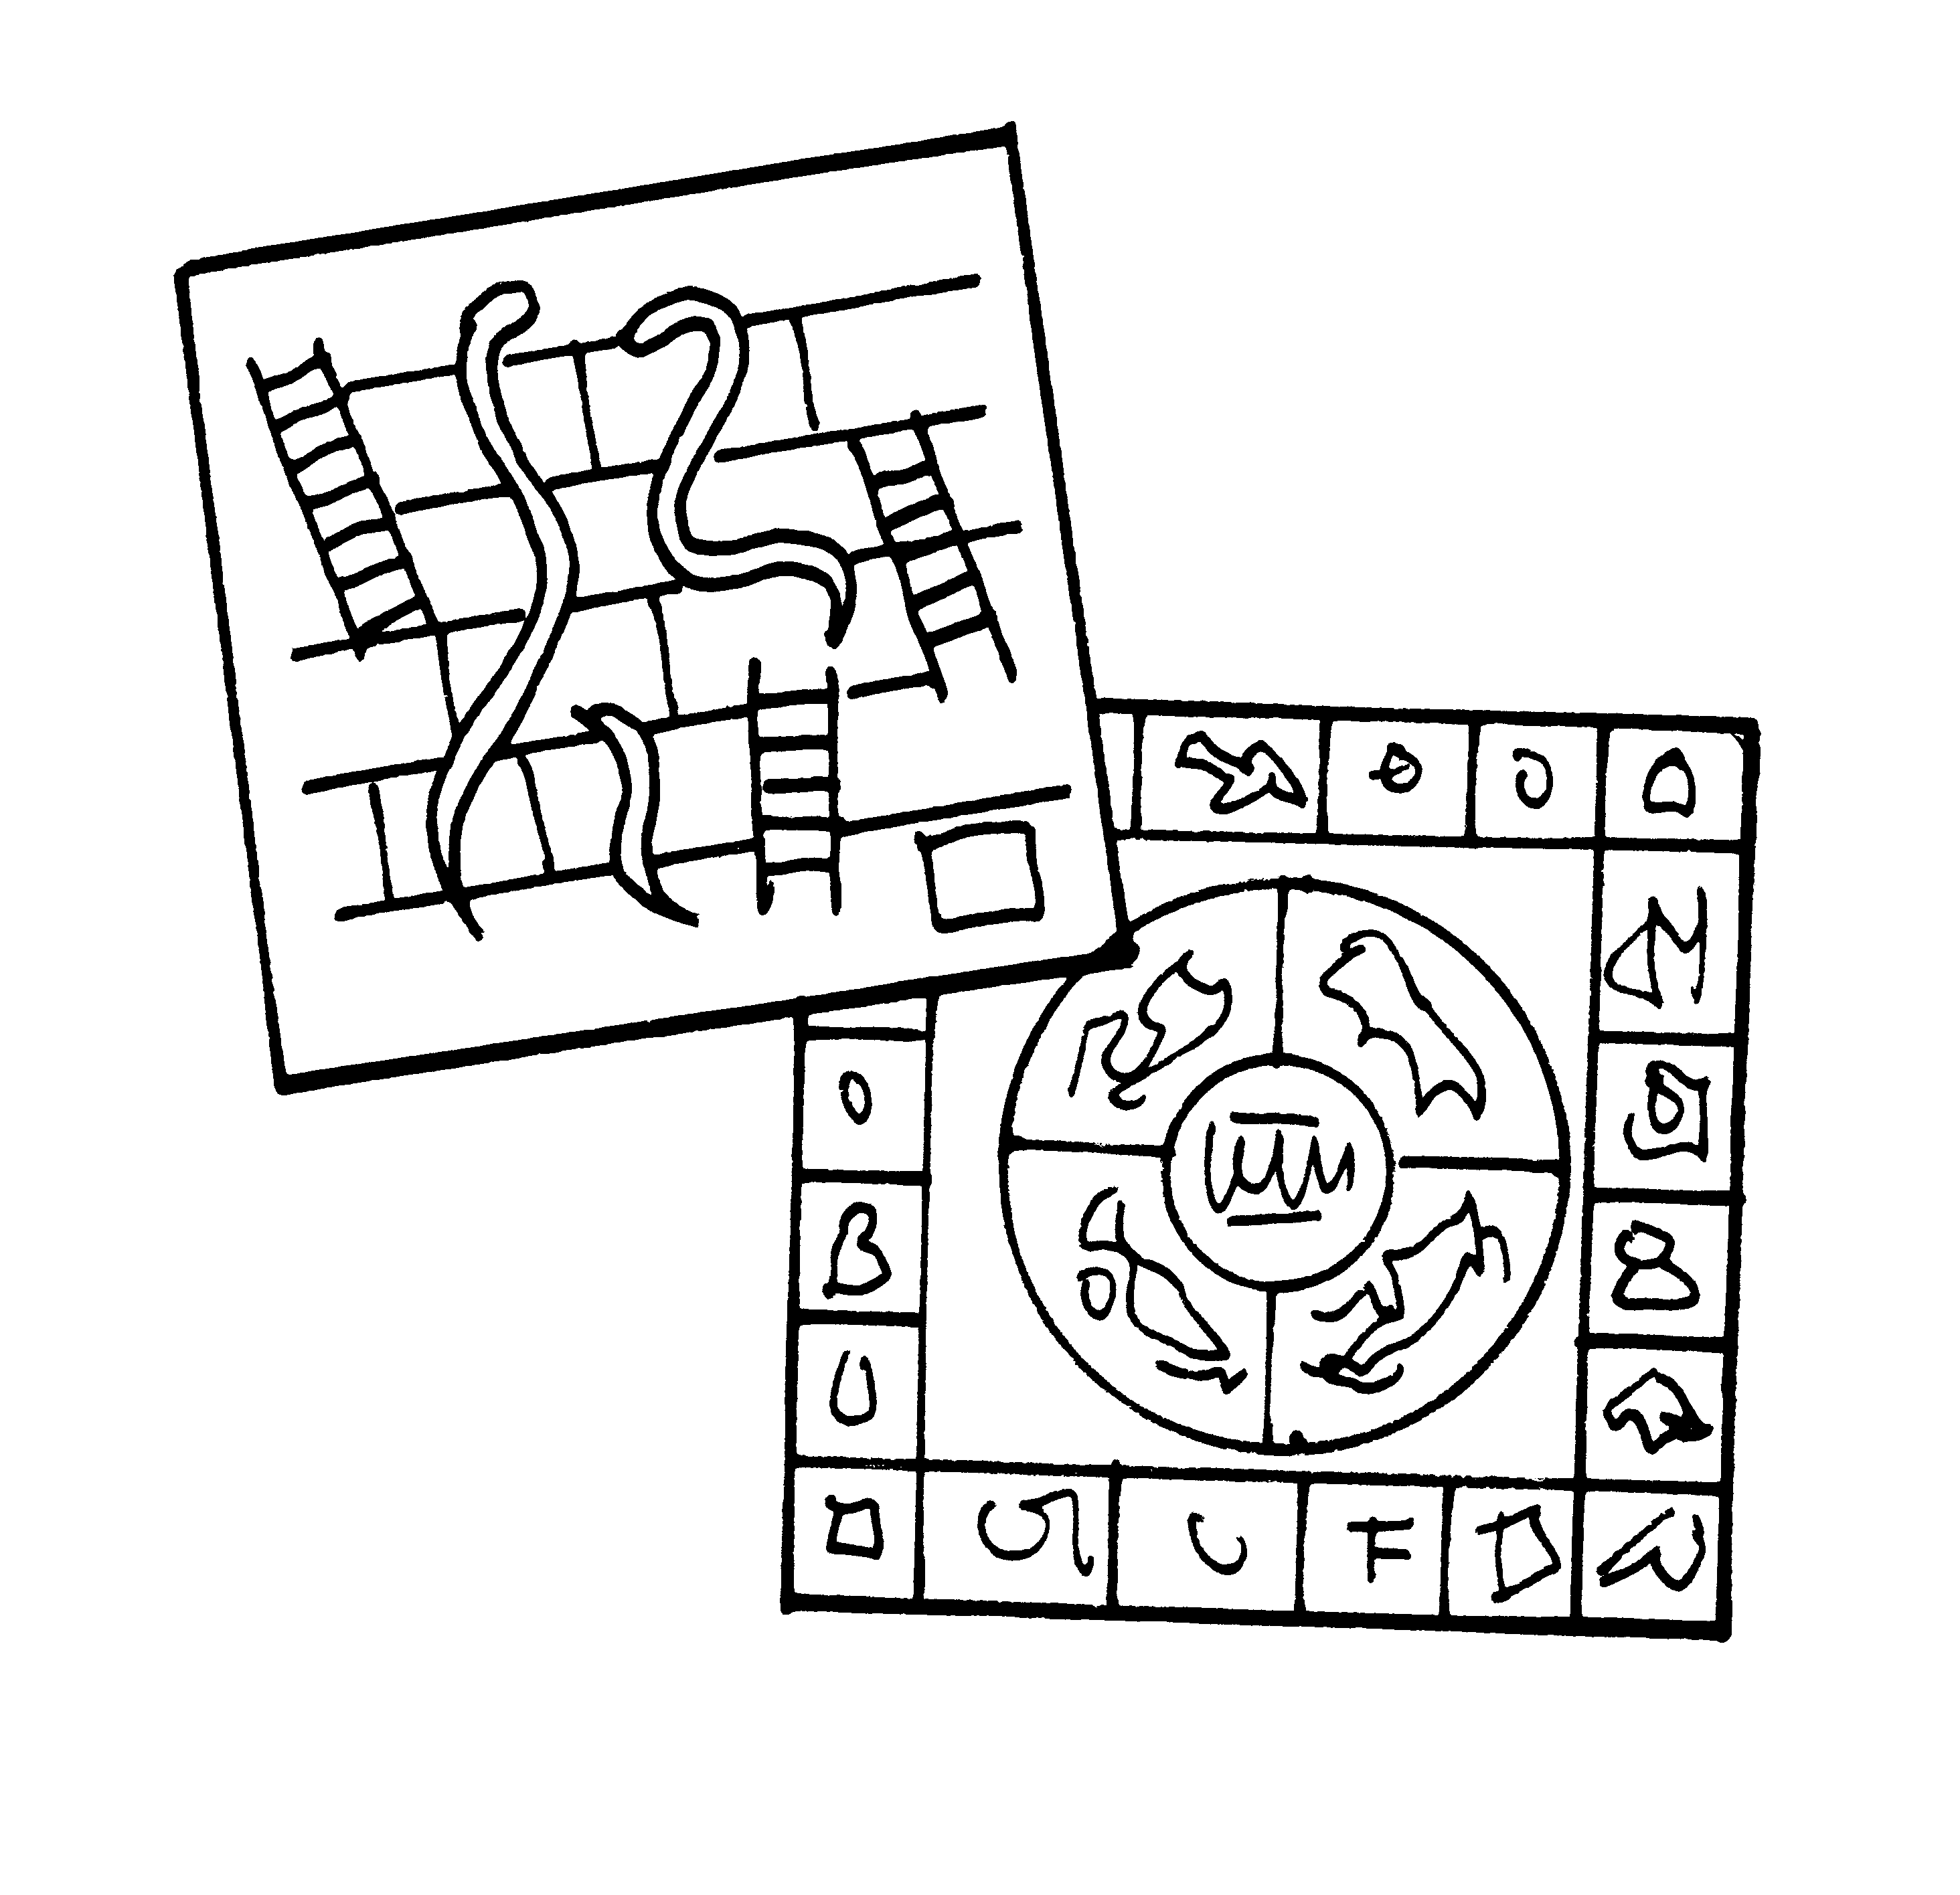

__ __ _1_
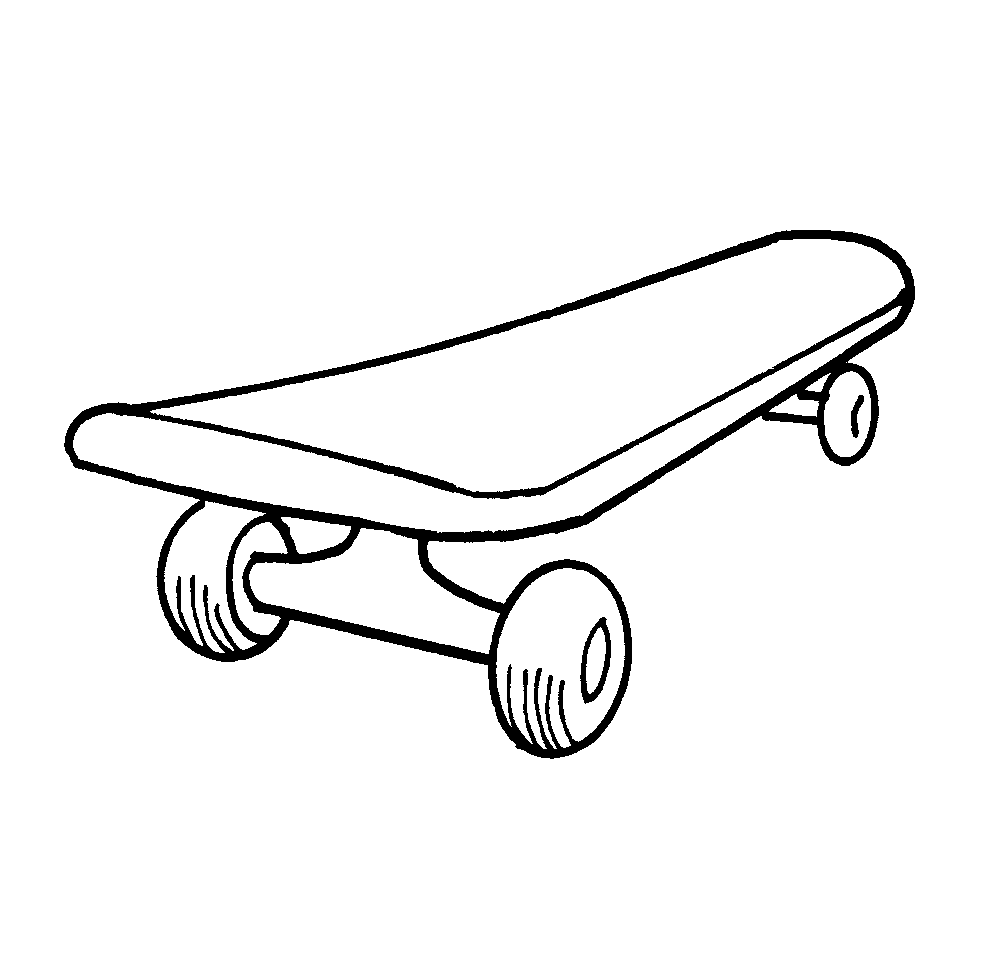
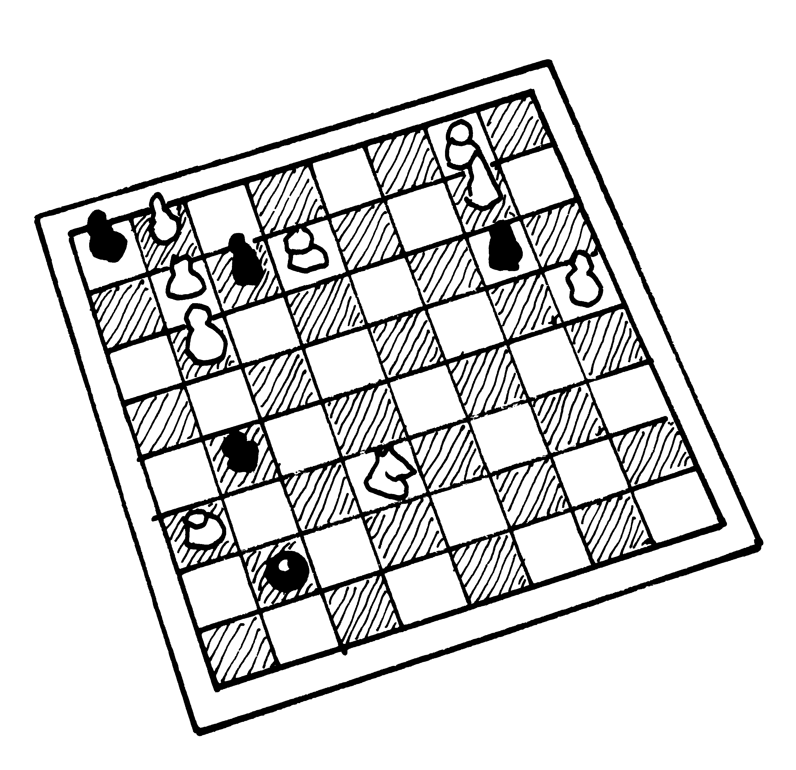
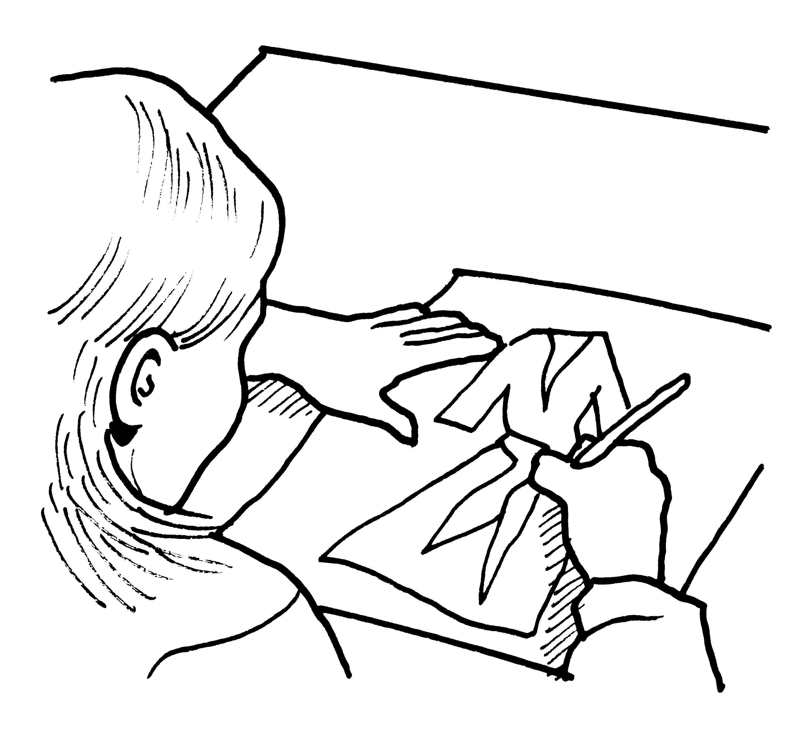

__ __ __

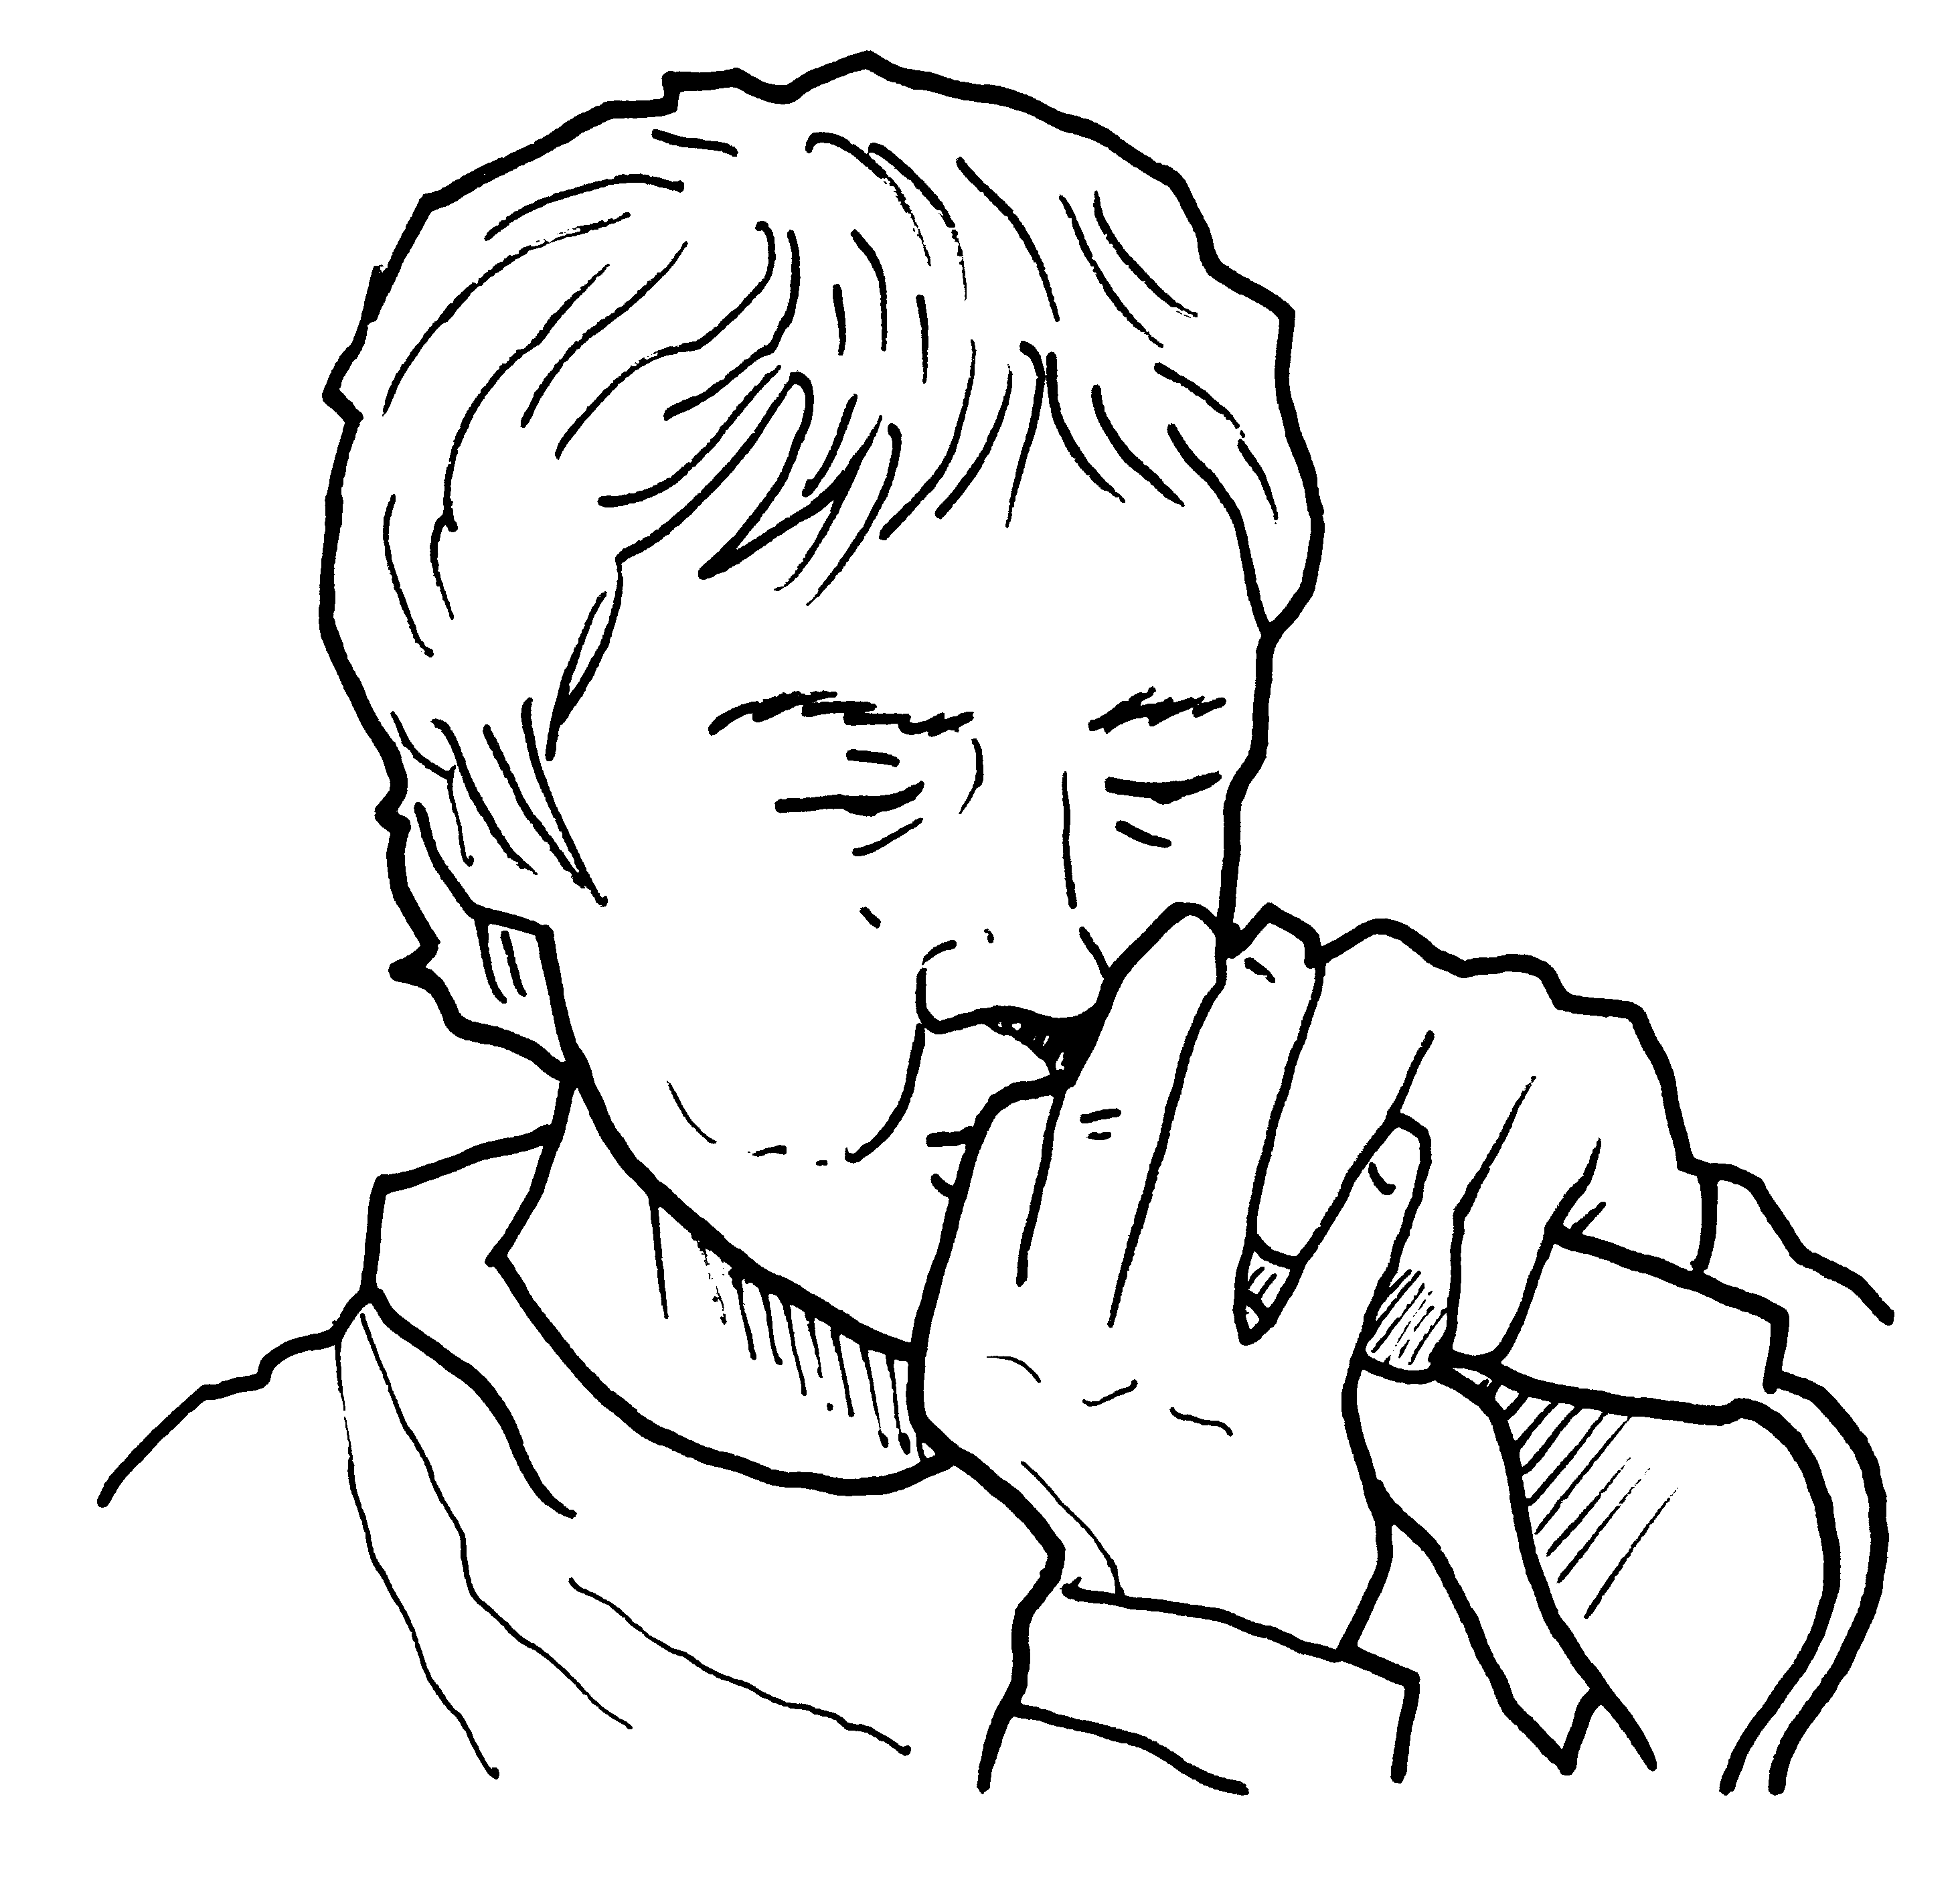
②Circle the music words. Mark / 10

  beat box | someone | tempo | skating
chess | melody | opera | tune
rhythm | bass guitar | sail | improvisation
kick | ride | board | notes
dry | harmony | climb | rhyme

Total unit mark / 15

