Name: | Class:

① Listen and tick () the things Jenny has
already done. Mark / 5


❶ The History Museum. ❷ The river.
❸ The university. ❹ The castle.
❺ The Roman walls. ❻ The shops.

②Read and complete. Mark / 10

tidied bought lost heard took opened put
shouted looked found felt
On Monday morning, Danny couldn’t find his new mobile phone.
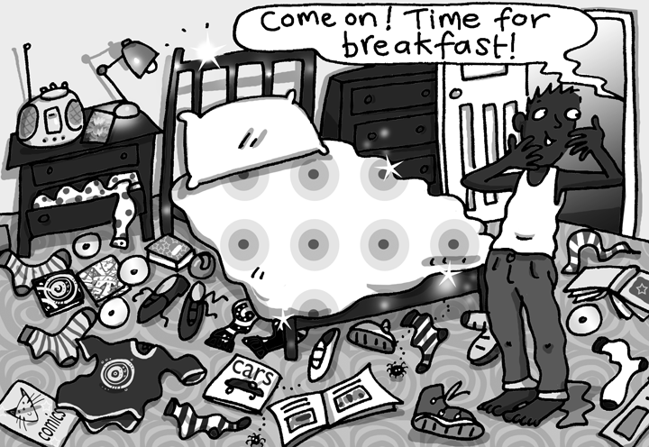
He (1) opened all the cupboards, (2) _____ everything out
and (3) ________ it on his bedroom floor. I’ve just
(4) ________ my phone, Danny thought, ‘and I’ve already
(5) ________ it’!
‘Come on! Time for breakfast!’ his mum (6) ________ up the stairs.
‘I’ve (7) ________ everywhere and I still haven’t (8) ________ it!’

Danny thought.
Then he (9) ________ his phone ringing. He (10) ________ something

moving in his pocket. ‘My phone!’ he thought.

‘Hello?’ Danny said.

‘Hello Danny. Can you come downstairs for breakfast now, please?’

‘OK, Mum’
After breakfast Danny (11) ________ his room for four hours!

Total unit mark / 15

